REST Web Services (REpresentational State Transfer)
REST term intruduce by “Roy Feilding”
What is WEB Services.
Web services are services that are exposed to the internet for programatic access there online api thst you can call from your code.

Web Services Characteristics

Client send HTTP req to server
Server send http resp to client

SOAP uses SOAP protocol
REST no protocol

ONLY XML in SOAP
No restriction in REST

WSDL is present in SOAP
NO WSDL or no Rules no Documentation

HTTP (Hyper Text Transfer Protocol)

Protocol means language or mechanasim for communication i.e. HTTP is way to exchange the informaation online.the stuff you exchange over internet is called as Hypertext.
HyperTest is Structured Form of Text, it contain logical links with other Text and the links are called as HyperLinks.

HTTP Method
GET
POST
PUT
DELETE

Status Codes
200 ---> Success
500 ---> Server error
404 ---> Not Found

Why Send Status Code?
-->we can not send user define error msf back to user so we can send the status messags so the code developer can code if any erro occur then nevigate to the Home page

Contend types
text/xml
application/json

Summery
1)Resource Based URIs
2)HTTP methods
3)HTTP Status Codes
4)Message Headers
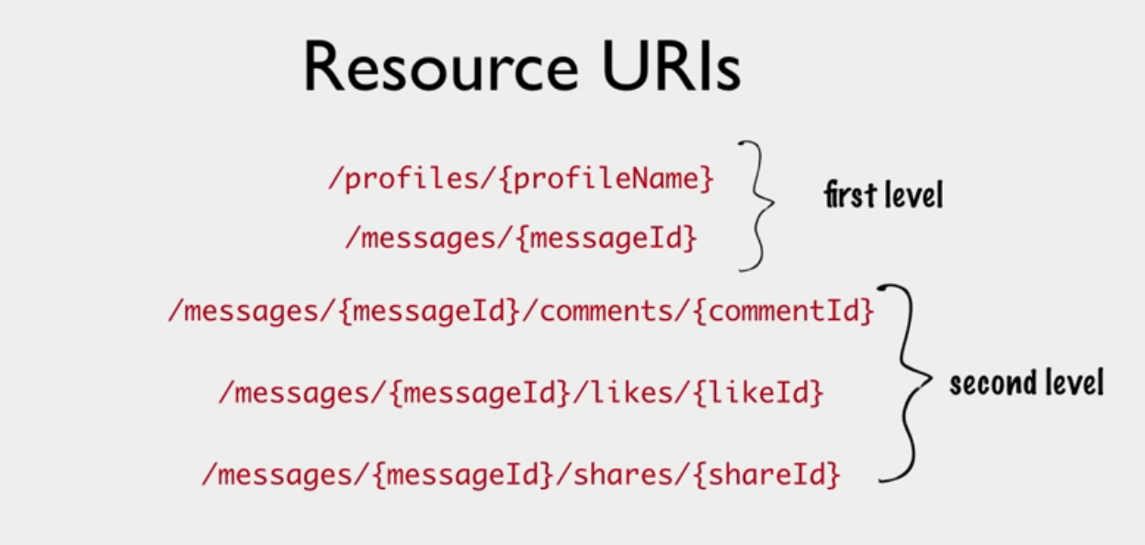

Here we can achive one to many Relation in between message and (comments ,Shares , likes )
Dont use getComments getLikes as directory.
Above URIs anre instance URIs because here we are generating request for only oner instance using its ID.

Getting Message : /messages/{messageId}

Getting All Messages: /messages Collection
Getting all comments for message 2: /messages/2/comments URIs

Case 1:
/messages URI will return all the messages so we need ti filter the result.

Filtering Result

Starting point
URI will be: /messages?offset=30&limit=10
page size (How ment records wants.)

Custom Filters

URI will be:/messages?year=2018
we can use custom filter with peginations.
URI will be: /messages?year=2018&offset=30&limit=10

There 2 types of URIs:
Instance resource URIs
Collections resource URIs

we can use query parameters for pagination and filtering the collection URIs.

URIs

/getMessages.do?id=10 Action based URI
Getting the message information whose id =10

Rest URI would be: /messages/10
/postMessages.do?id=10 ----> /messages/10
/deleteMessages.do?id=10 ----> /messages/10

Different action can be preform by using HTTP Methods

Common Method:

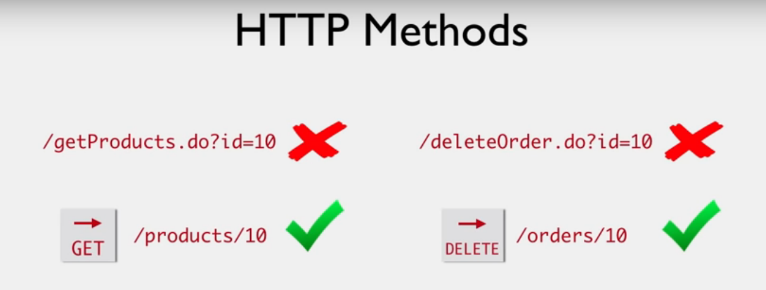
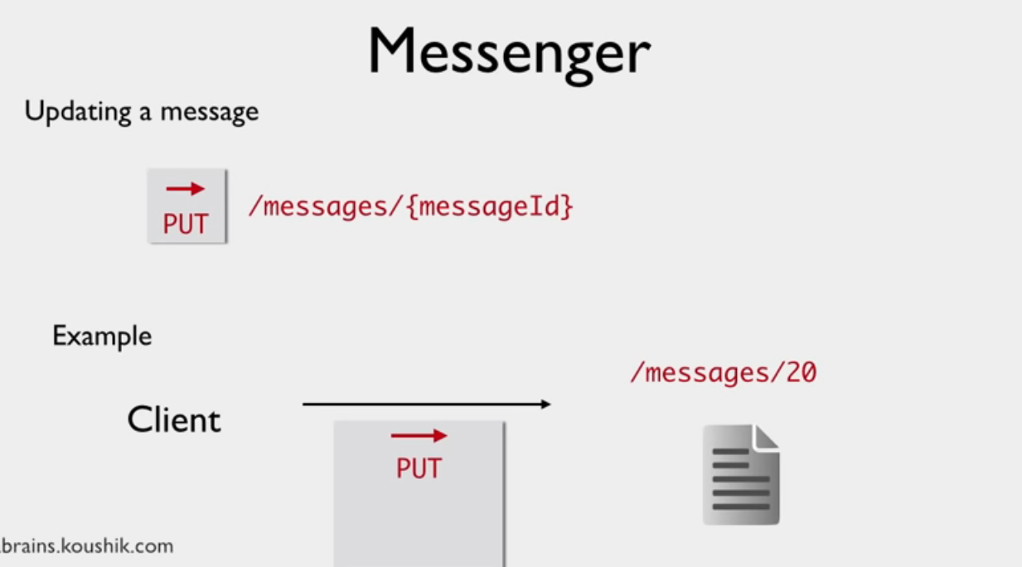
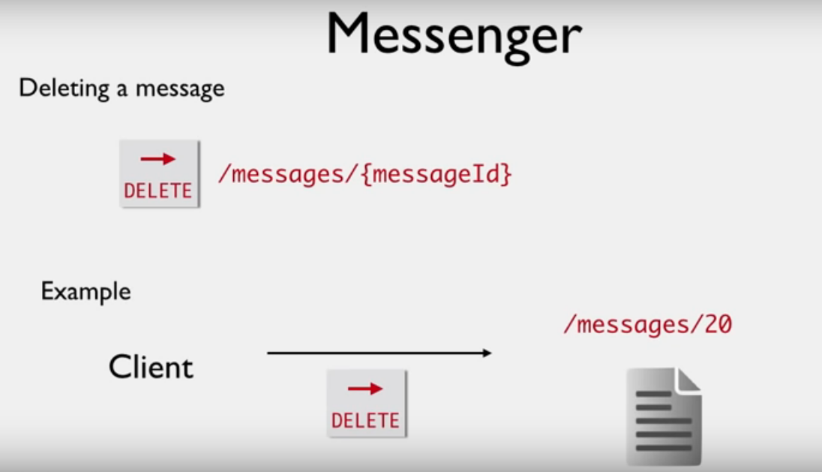
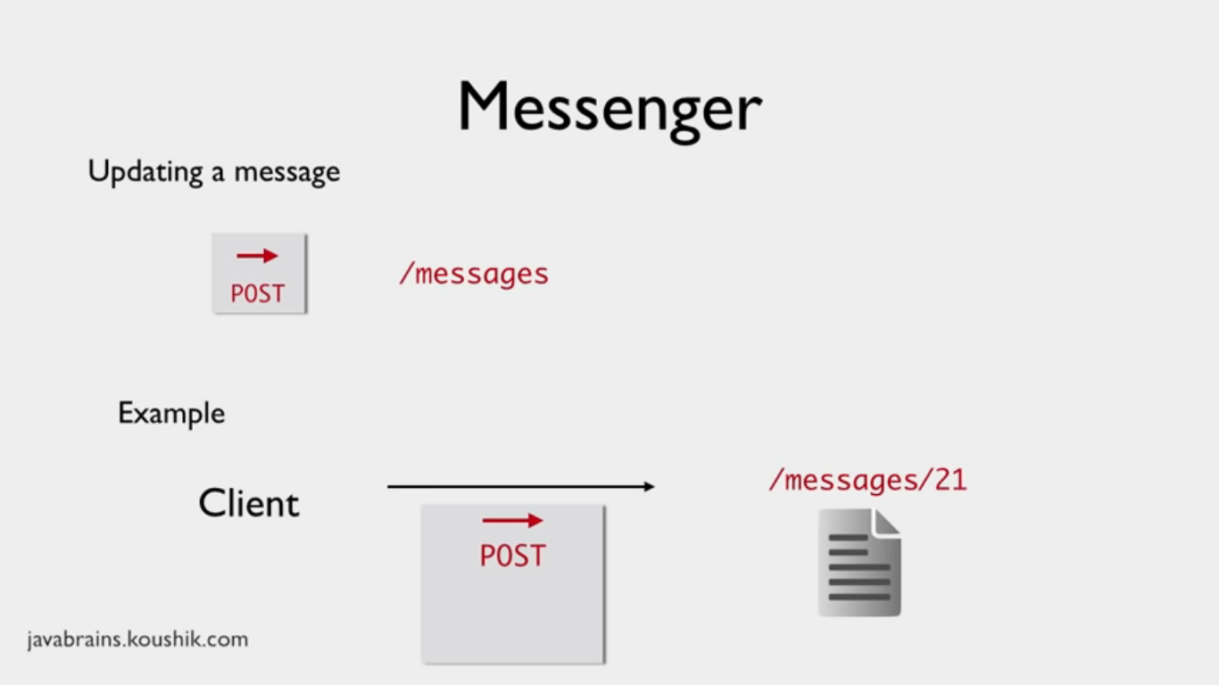
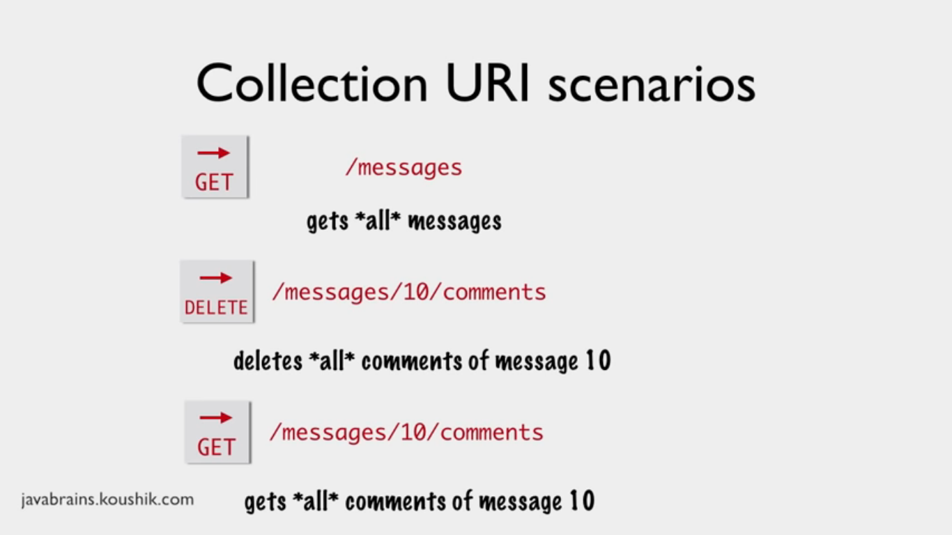
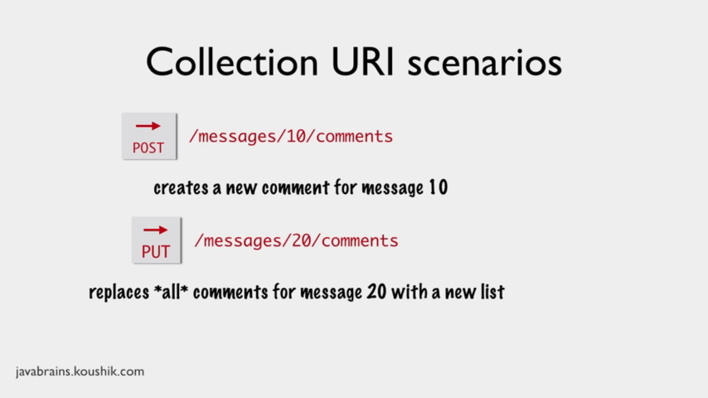

HTTP Methods:
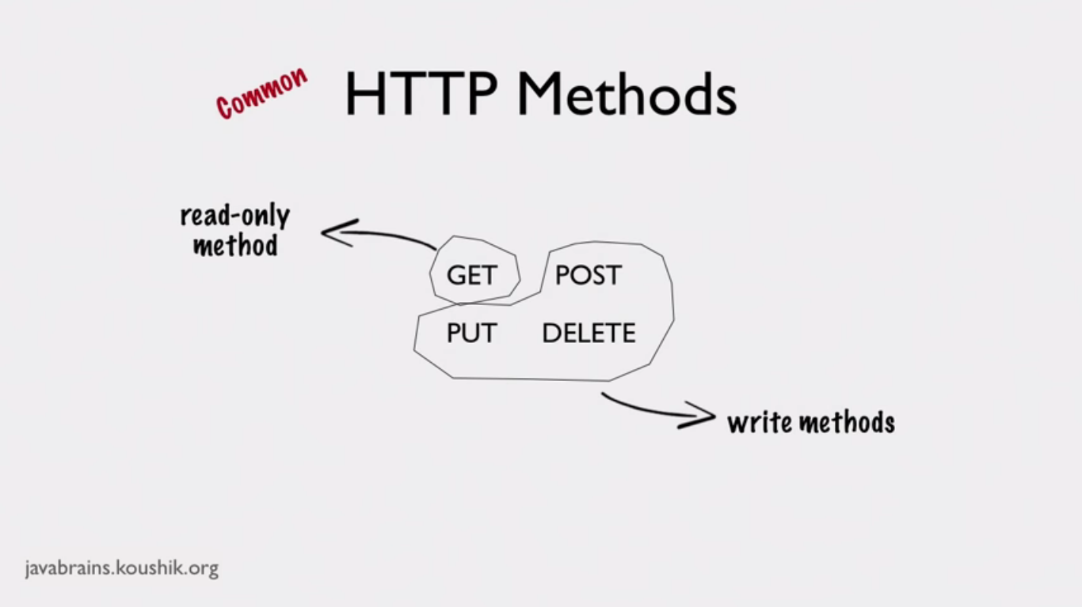
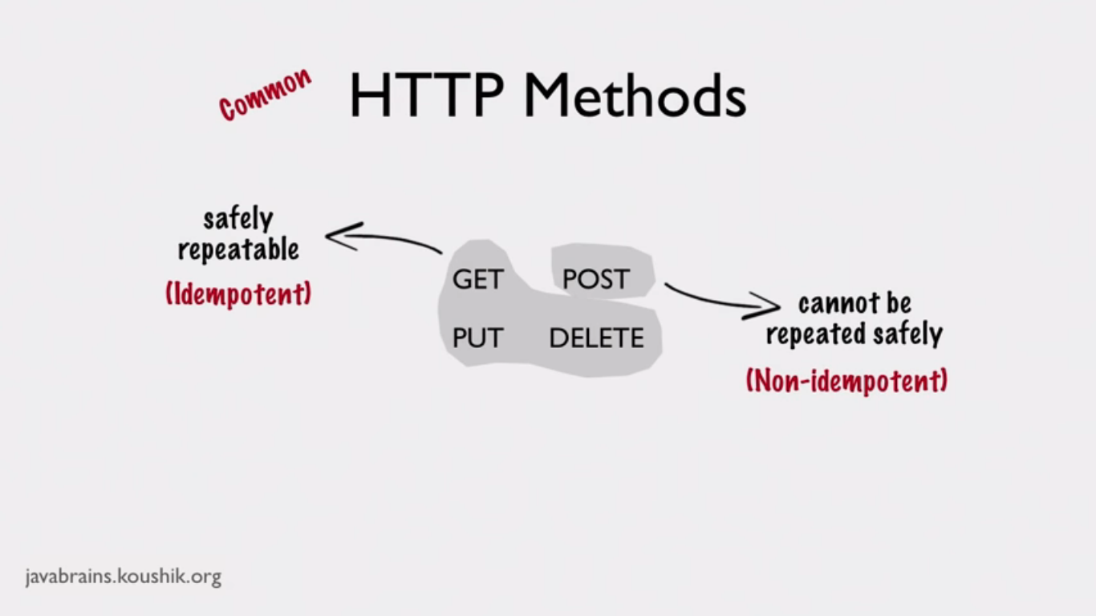
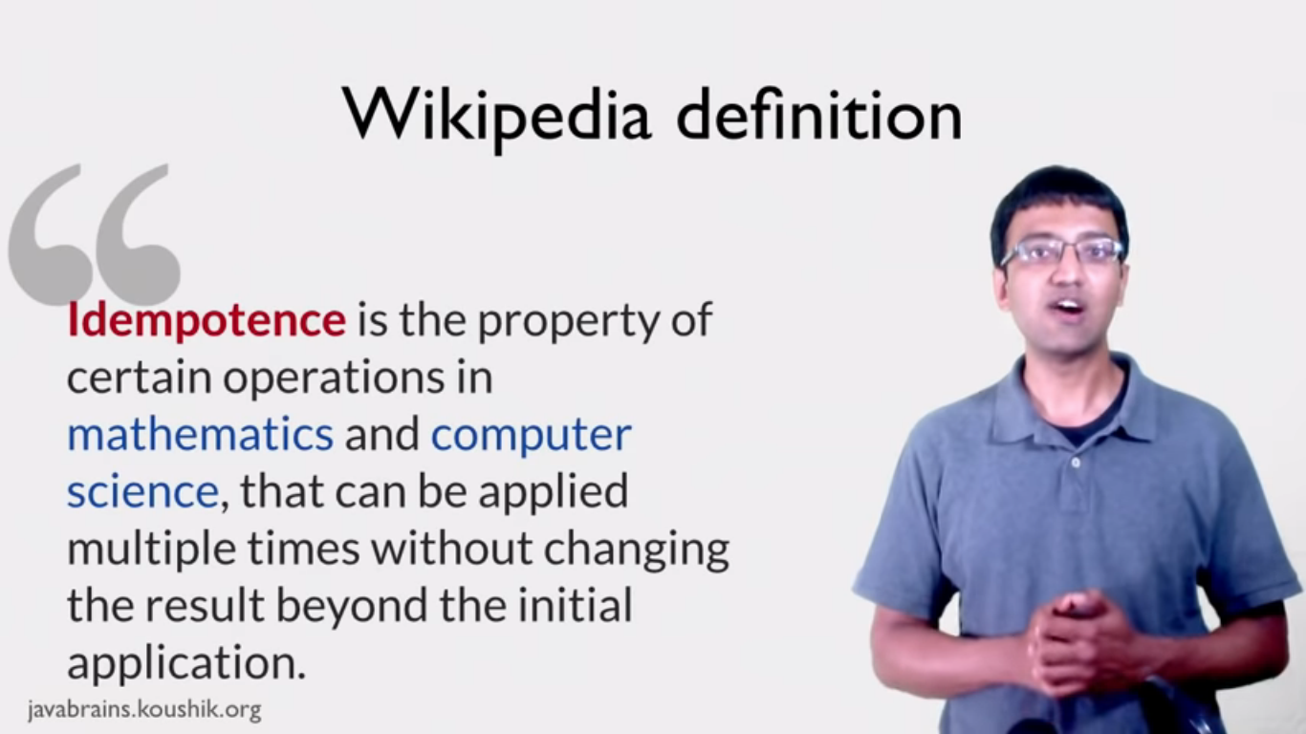
PUT is Idempotent POST is Non Idempotent.
WEB Application:

Client sends req to Server and gets response in terms of HTML Content but in RESTFul Web Services Responce is in term of “JSON/XML”

Responce Codes:

1XX All the codes starts with 1-- are informational Codes.
2XX All the codes starts with 2-- are Success Codes.
200 OK
201 Created: Indicate successful resource creation. Used in POST Request.
204 No Content: Used when no need to send any responce back used when delete the record
3XX Redirection: redirect the request to other resource
302 Found
307 Temporary Redirect
4XX Indicates sClient ERRORs
400 Bad Request
401 Unauthorized Not allow to sign in
403 Forbidden Allow to sign in but not allow to access resources.
404 Not Found
405 Unsupported Media Type Clients req format not understandable by server
5XX Server Errors
500 Internal Server Error ex: when runtime Exceptin occut send 500 status message.

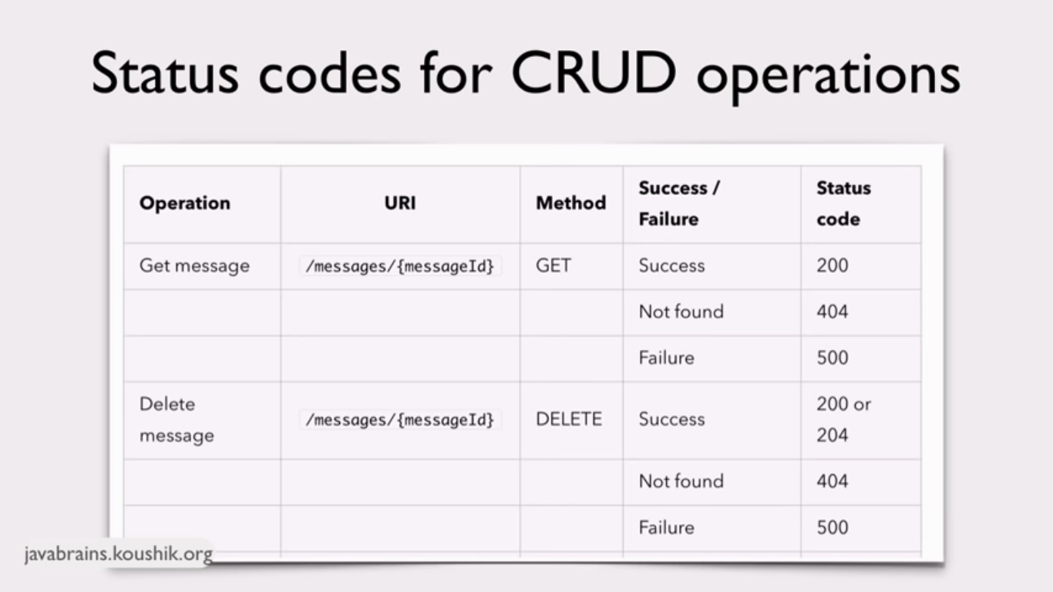
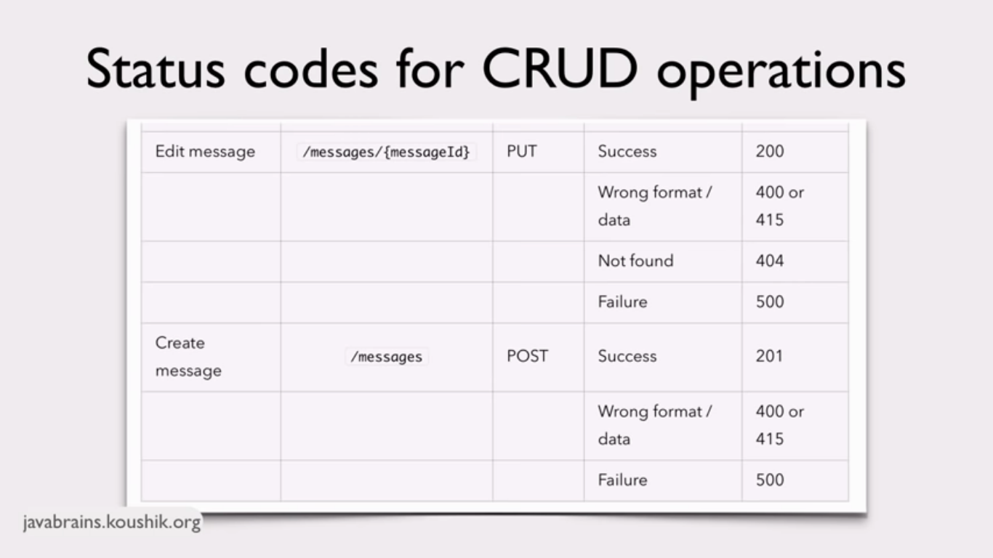

HATEOAS:(Hypermedia As The Engine Of Application State)

We can provide hyperlink as well as other uris in Response.

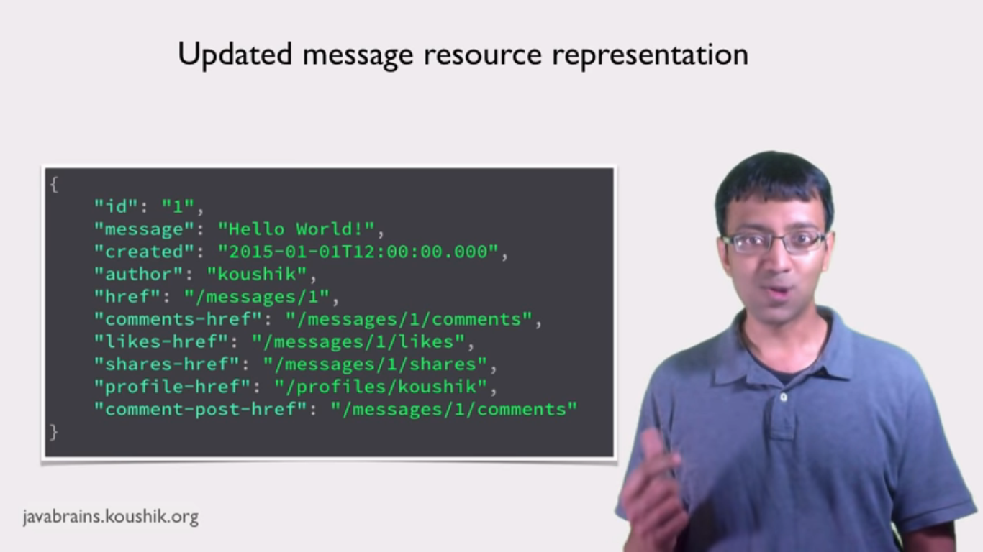
Here we providing URIs in response but href name are need to keep iin mind.
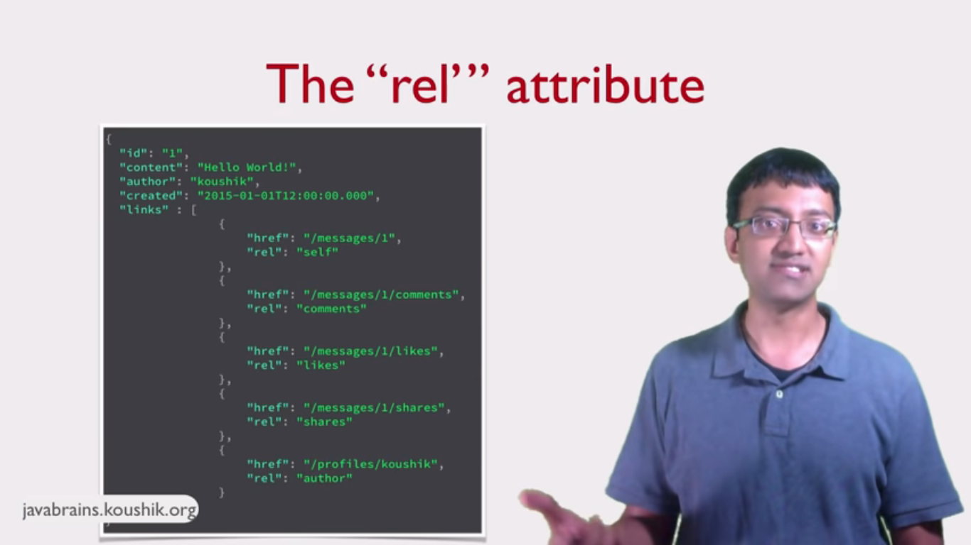
Here by using rel we provide simple name to URI.

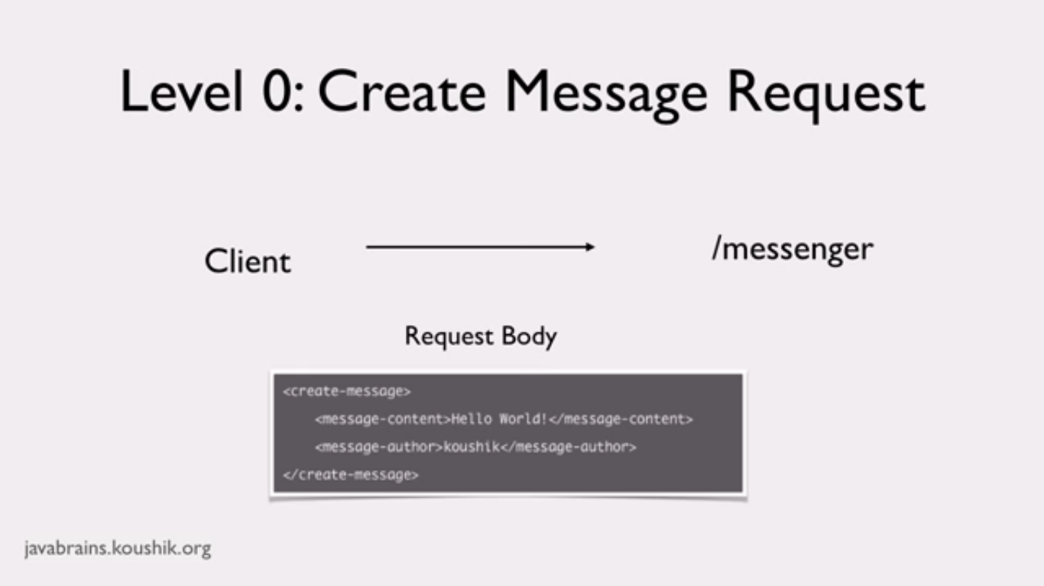
Richardson Maturity Module:
This module is used to decide “is this API is Fully RESTFull?”

Here we use same URI for Create Message as well as Delete Message.
All other information is defile in XML file.
LEVEL 1:
Individual URIs for each request
LEVEL 2:
Use different HTTP methods and Status Codes to do different operations.
LEVEL 3:
Responses have links that the clients can use.

What is JAX-RS?
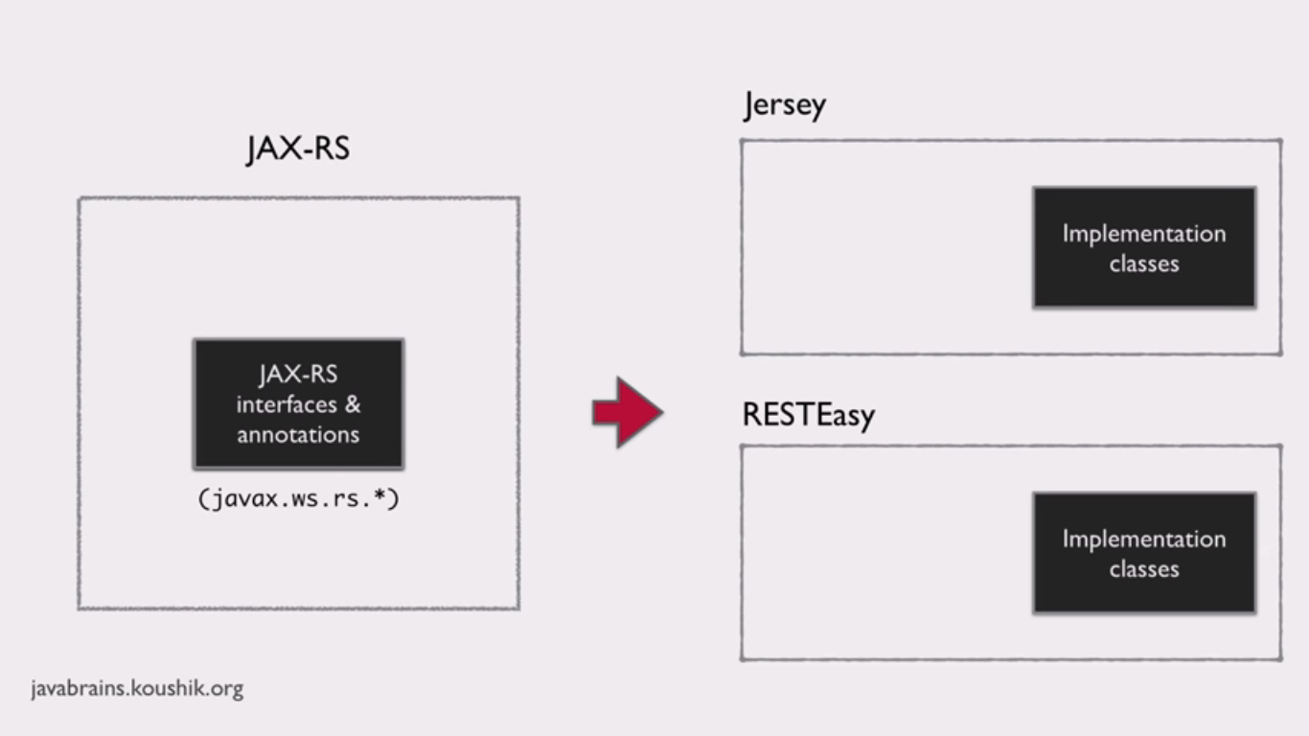
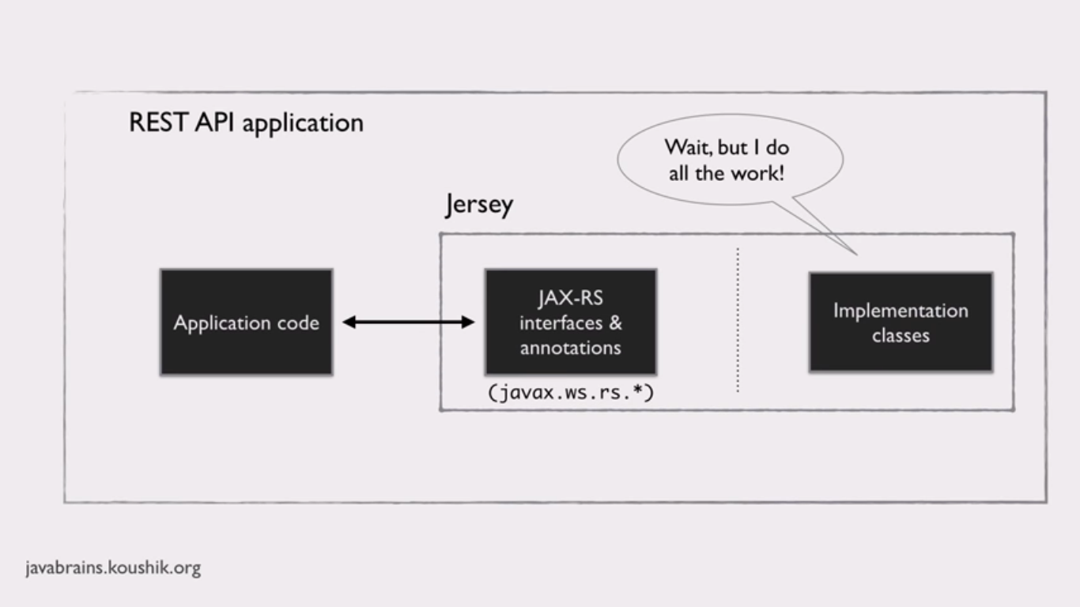
In the JAR file JAX-RS interfaces and annotations are included.
Jersey is reference implementation for JAX-RS specification.

Environment SET-UP:
Download Latest Jersey jar file from jersey.java.net.
Steps:
Create new project-->Maven Project-->Select archetype “jersey”
if it will not shows then add new archyetype
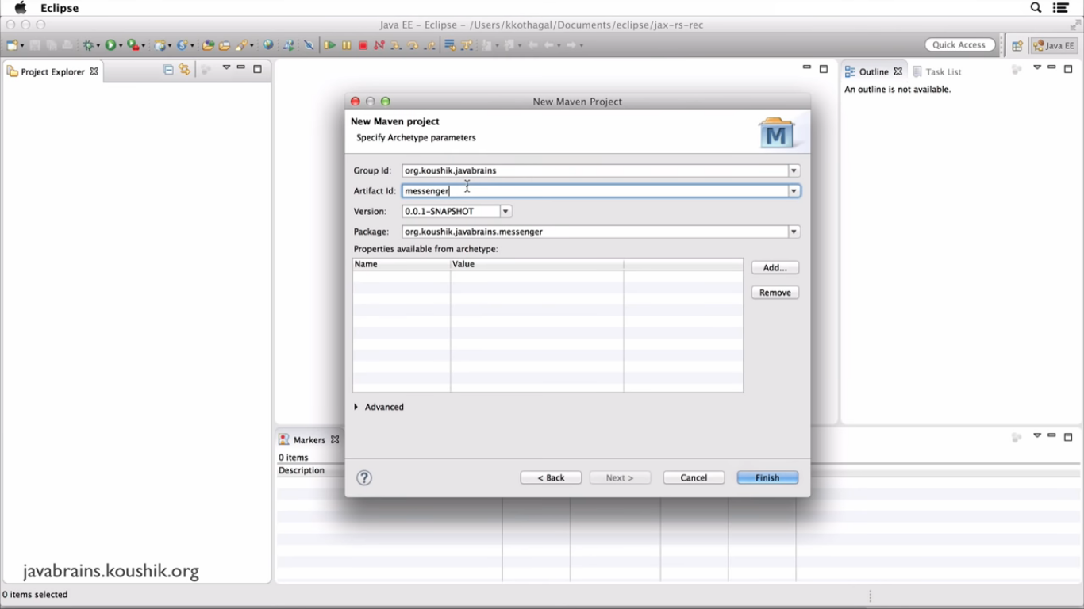
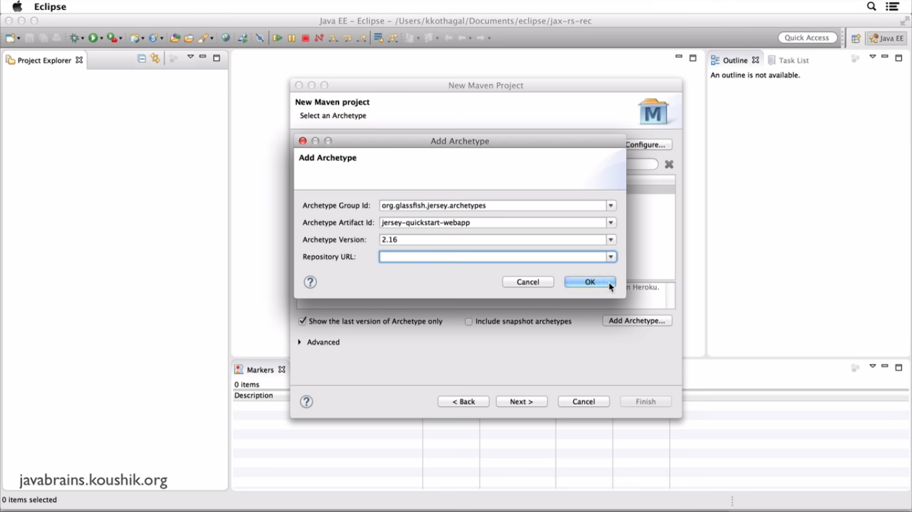

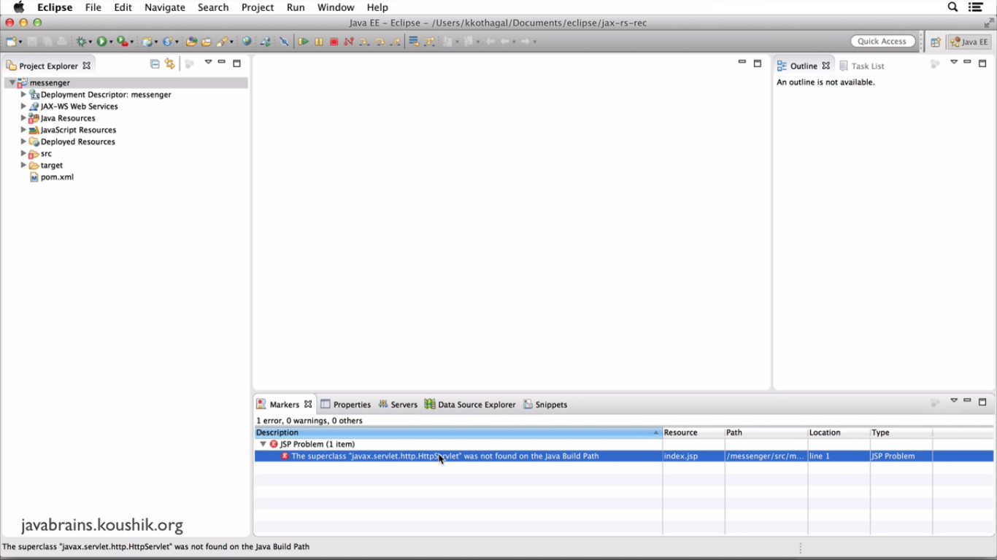
To remove above error from markers add servlet.api jar in build path.

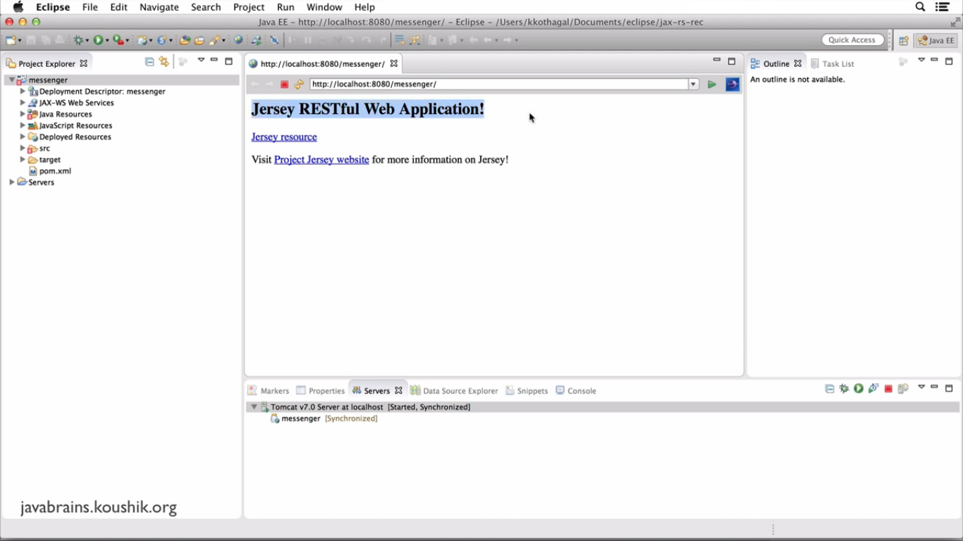
Above Page is root page.This page is startup page index.jsp
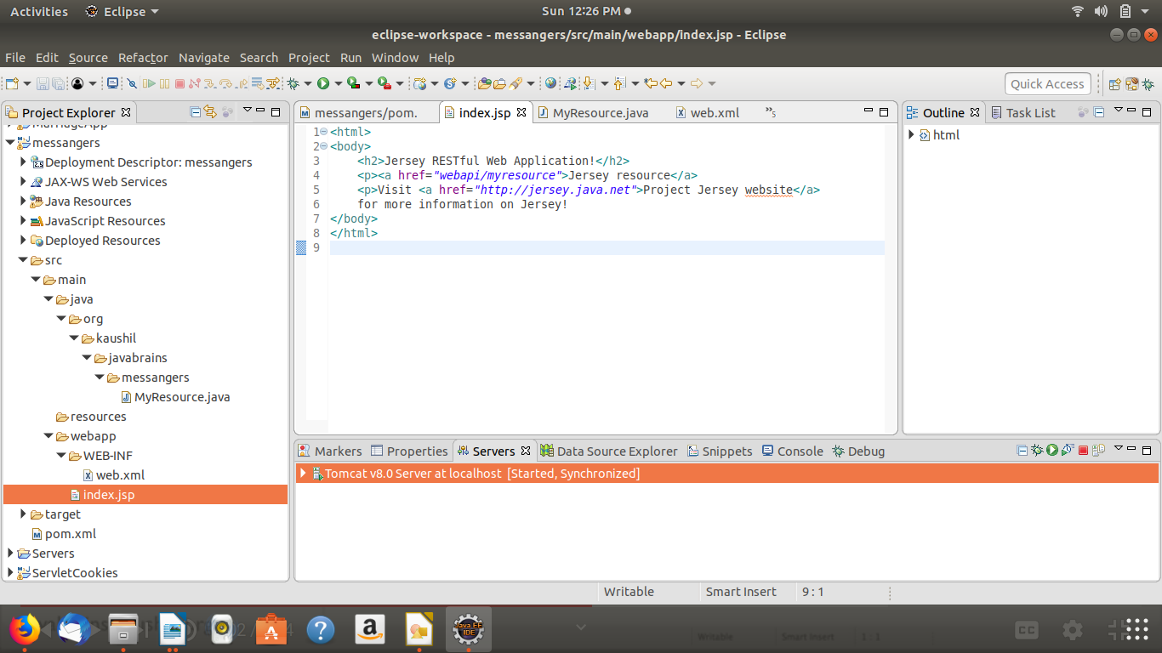
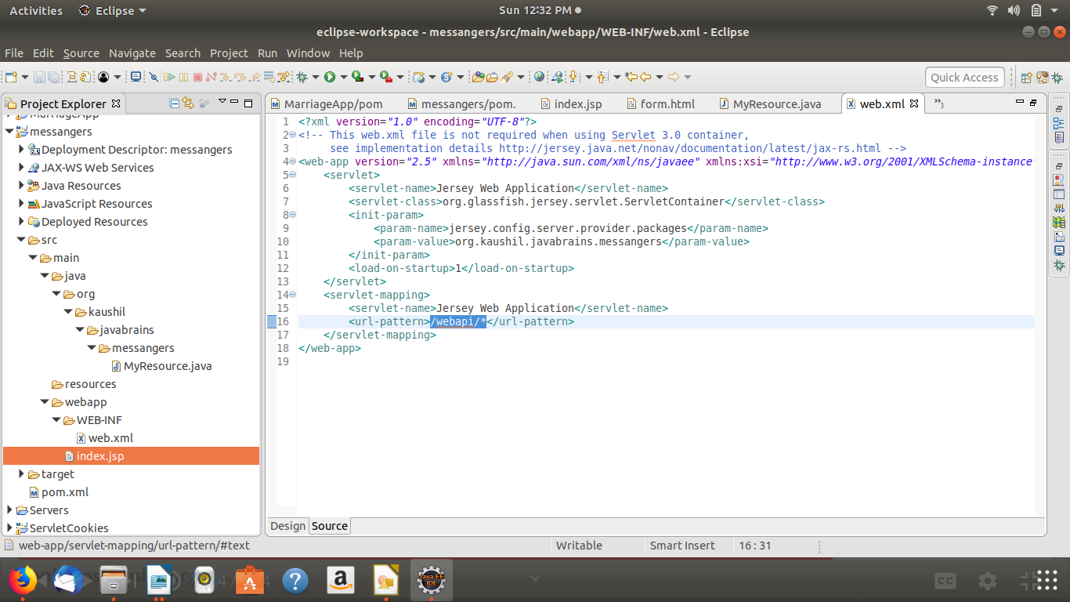
Default URI is : http://localhost:8080/messangers/
When we click on Jersey Resource URL is : http://localhost:8080/messangers/webapi/myresource

Here one servlet is configue “Jersey Web Application”. And this servlet is maped with “/webapi/*” url-pattern.so any request came fro this application should start with “/webapi/*” and this part is standard in all JAX-RS applications.
Init-paarm is tell tomcat that ‘when any request come for this api then search respected path annotation in given param-value package’
<param-value>org.kaushil.javabrains.messangers</param-value>
When we click on Jersey Resourceit has following url in index.jsp
<p><a href="webapi/myresource">Jersey resource</a>
<p>Visit <a href="http://jersey.java.net">Project Jersey website</a>
It will searches for URI path “myresource” and call respected java class and return response.

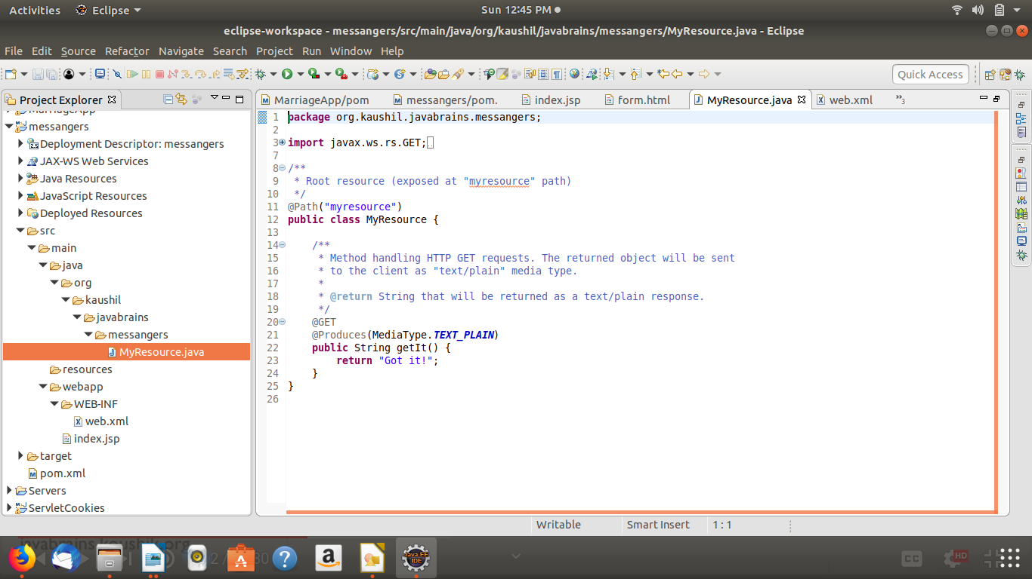
Now we create new URI fo Messages.
http://localhost:8080/messangers/webapi/messages

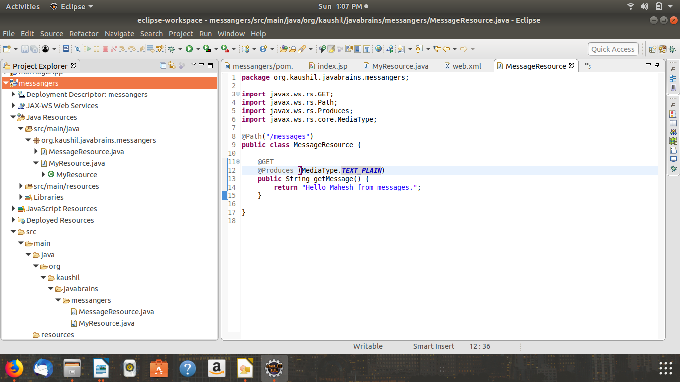
In the above java class we use @Path annotation for url
that means url with /messages will execute MessageResources.java.
@GET annotation is used for for which http request which method is called.
@Produces (MediaType.TEXT_PLAIN)
Used to produce output as plain text string.

Now we are producing xml document as a Response.

1)Create Message.java POJO.

In the Given POJO we use parameterized cunstructor as well as no-args constructor.
And also used 4 data members.
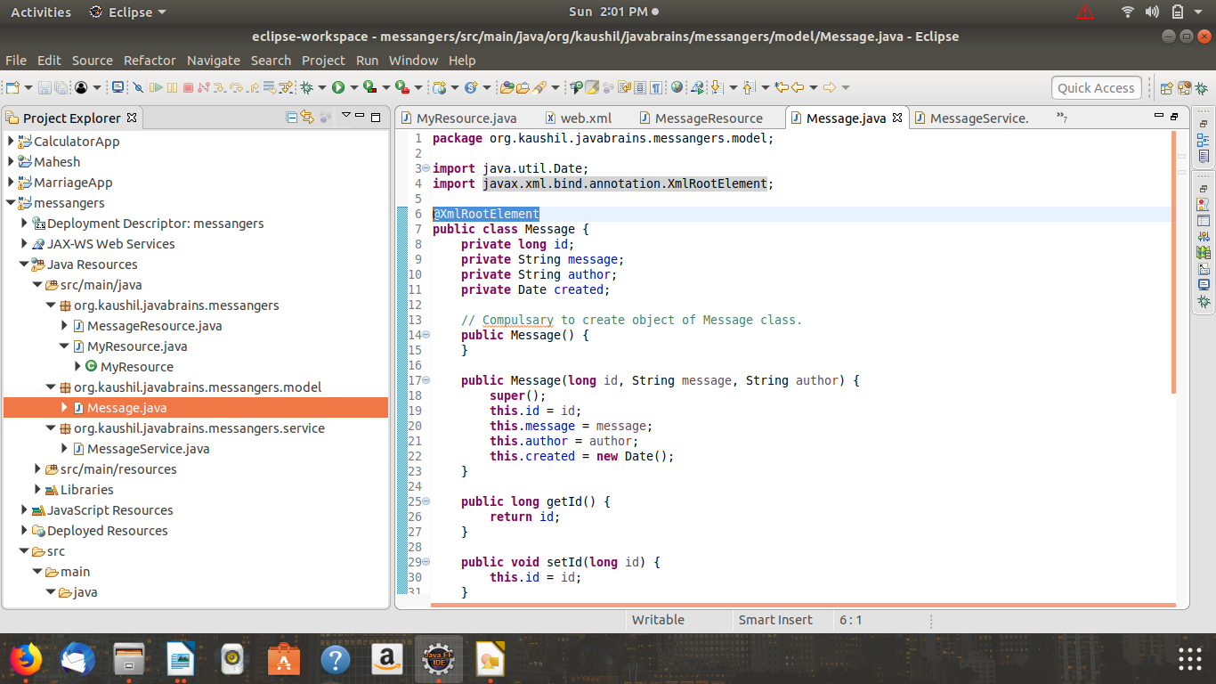
Here @XmlRootElement
Annotation is very important becase this annotation decides the root element of the response.
Otheswise it will give you following error.
MessageBodyWriter not found for media type=application/xml, type=class java.util.ArrayList, genericType=java.util.List<org.kaushil.javabrains.messangers.model.Message>.
This class to return the list of Messages.

Above annotation is used to convert bellow List<Message> to Application_XML.

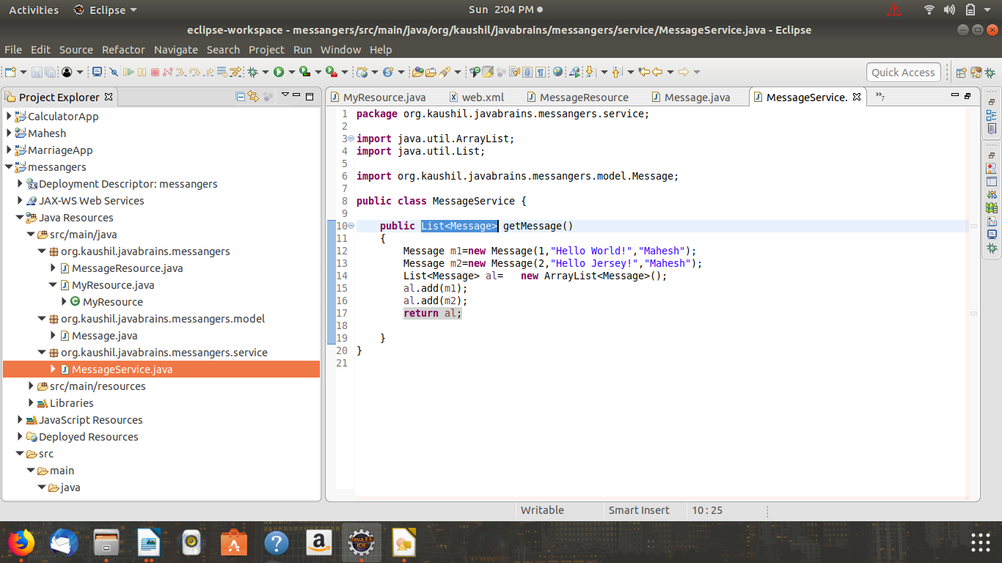
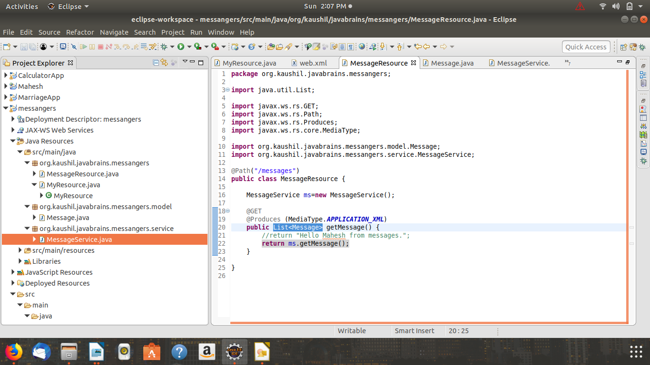

After Clean Build and refresh Restart the server and we gwt following xml in response.
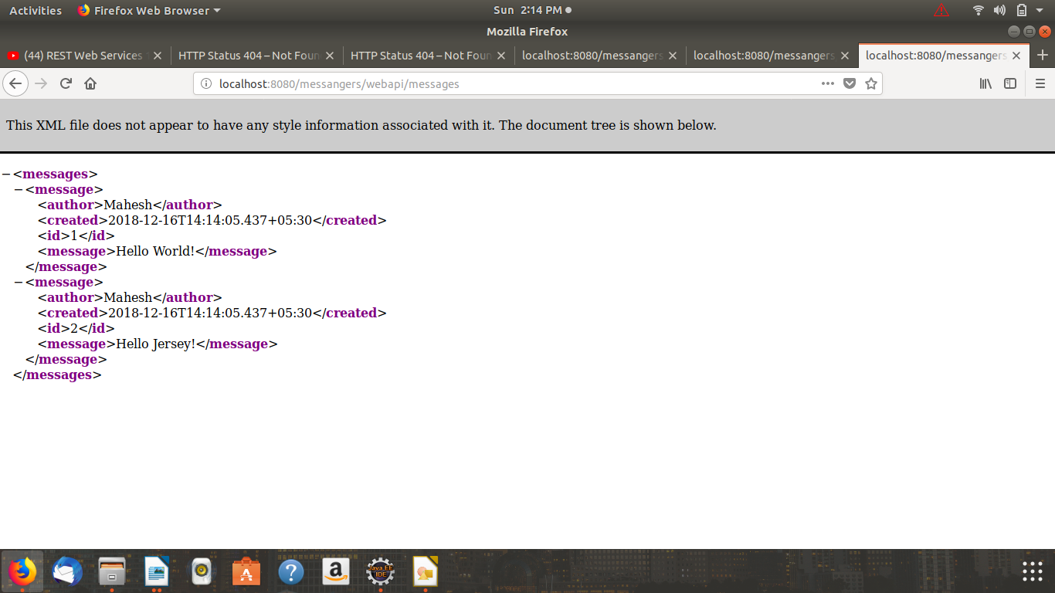
Insatll POSTMAN Client to Test REST Web Services.

CRUD Operation

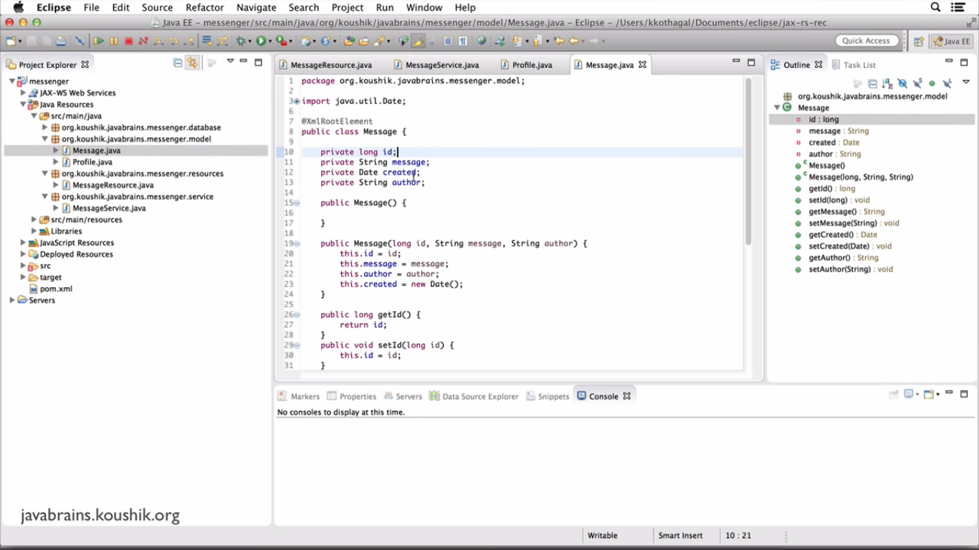

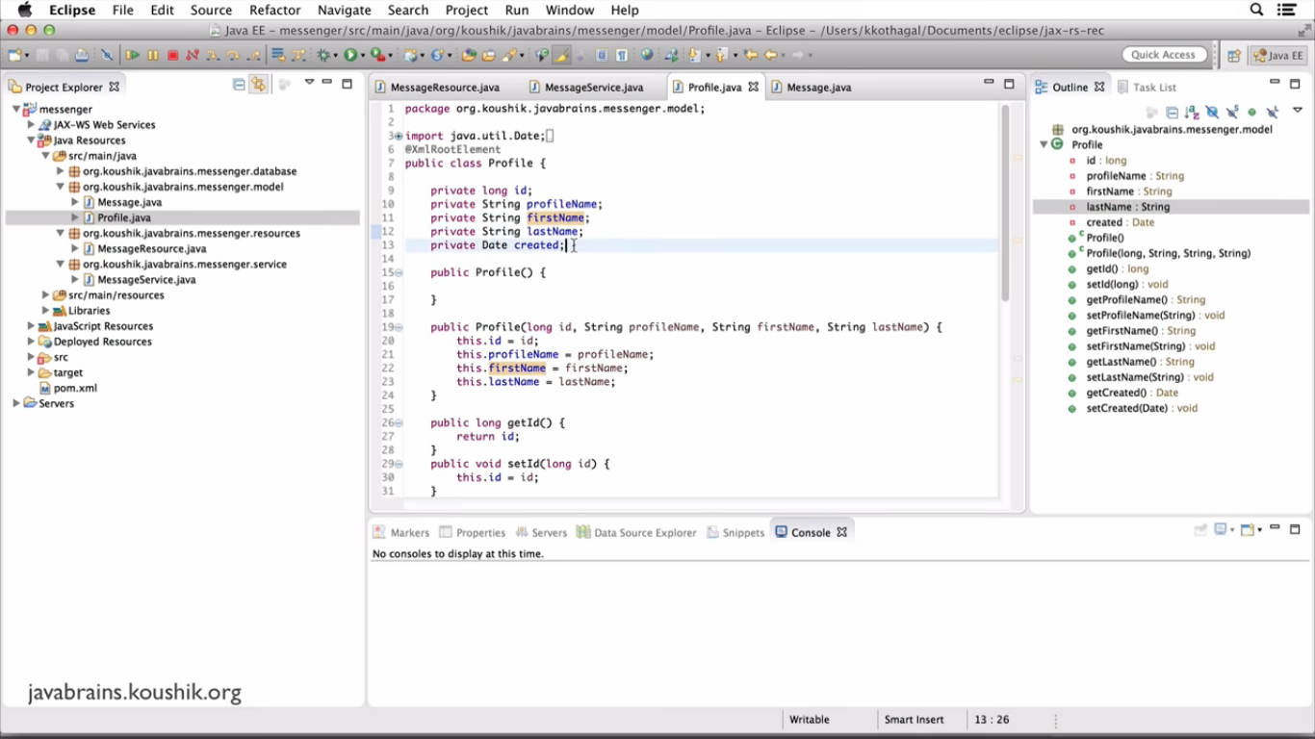
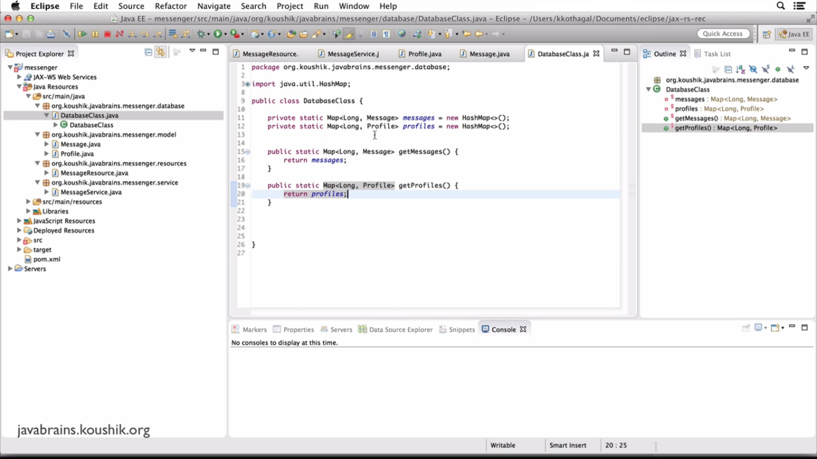
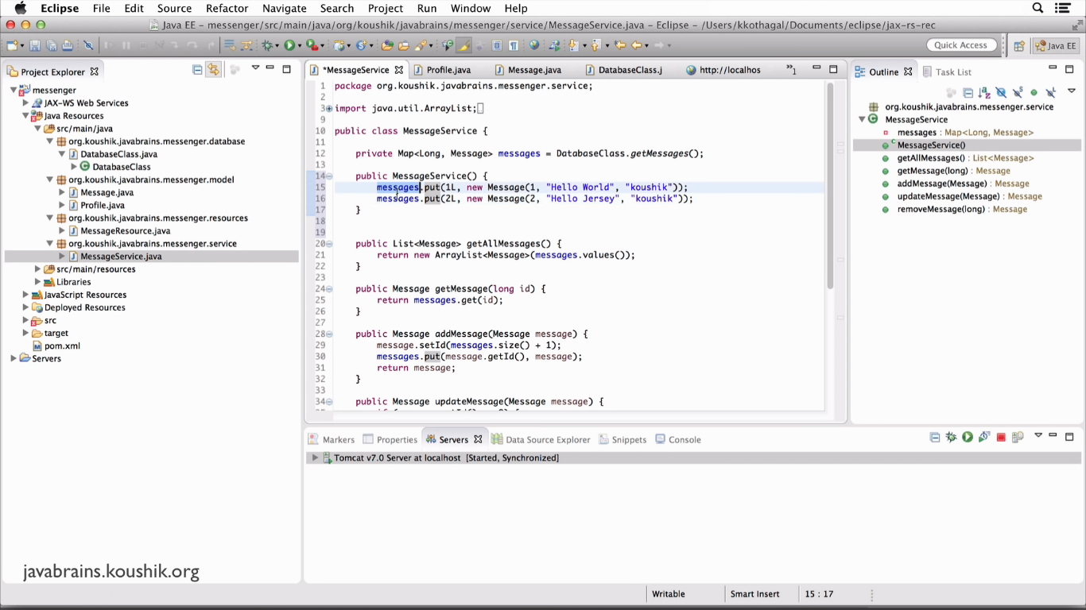
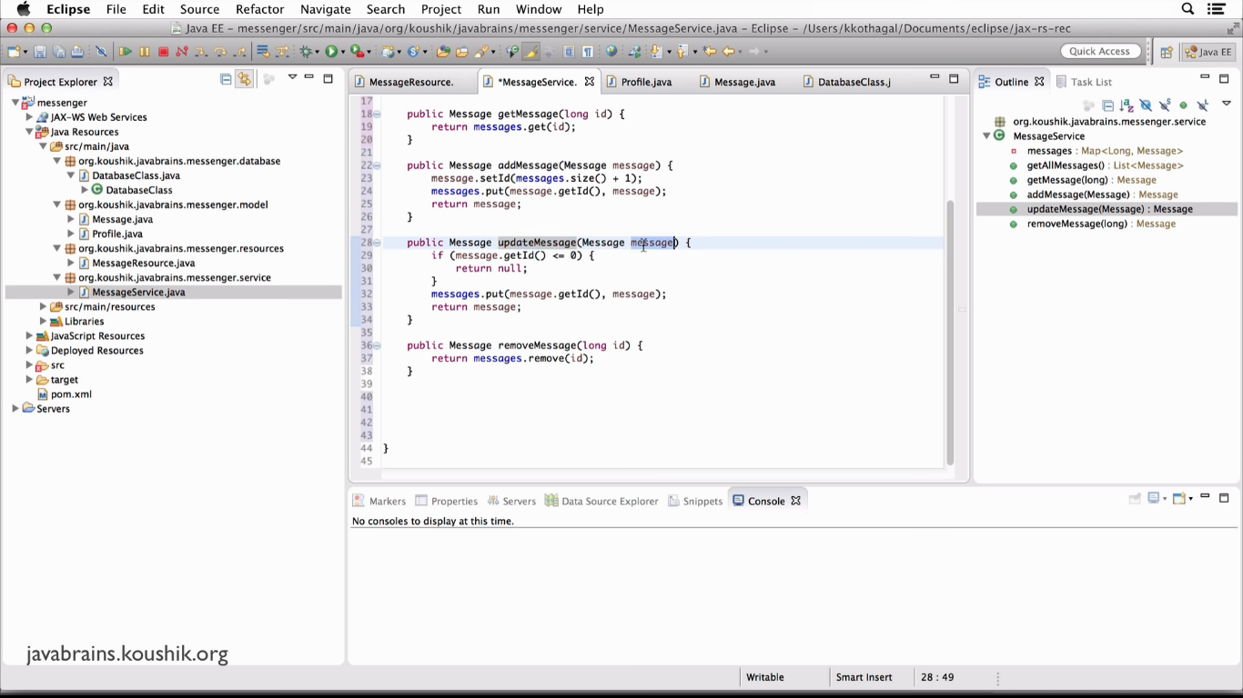

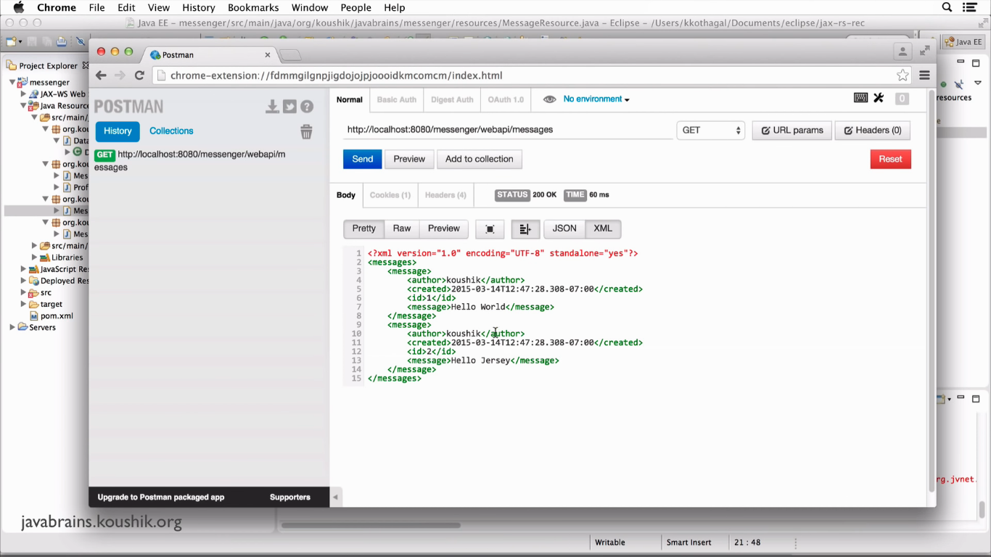
We Get All the Messages by Using http://localhost:8080/messangers/webapi/messages

Now Get Only One Object : http://localhost:8080/messangers/webapi/messages/1

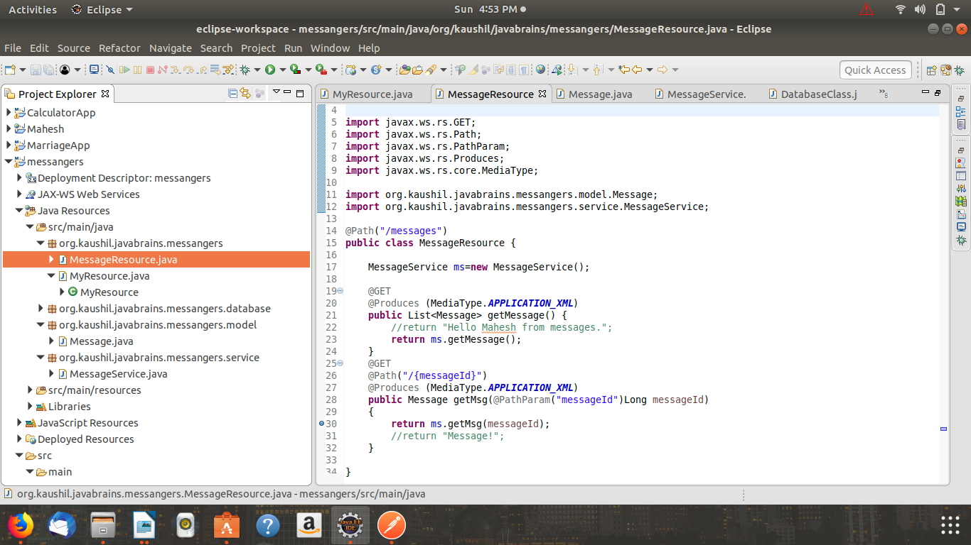
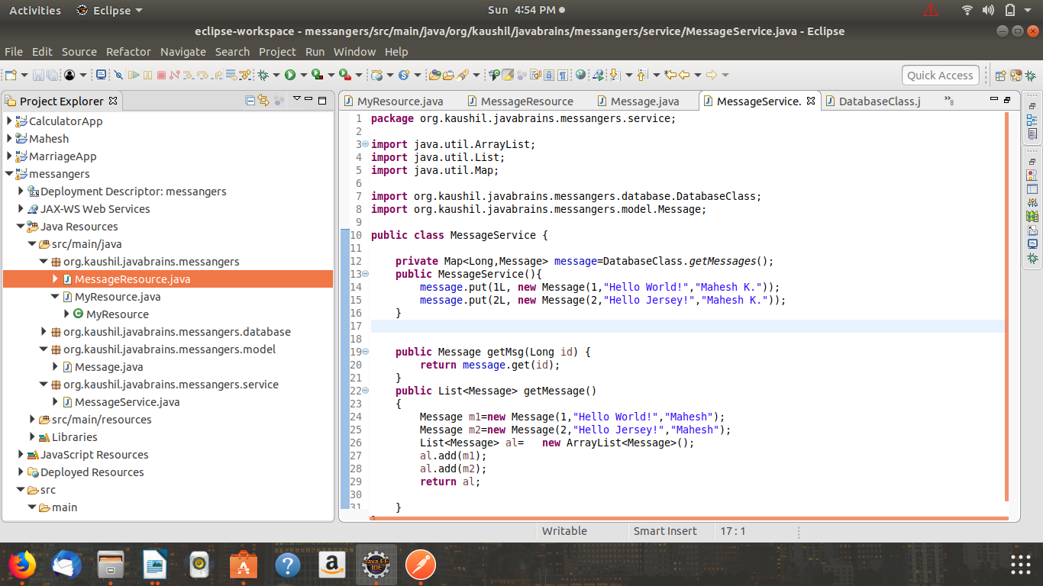

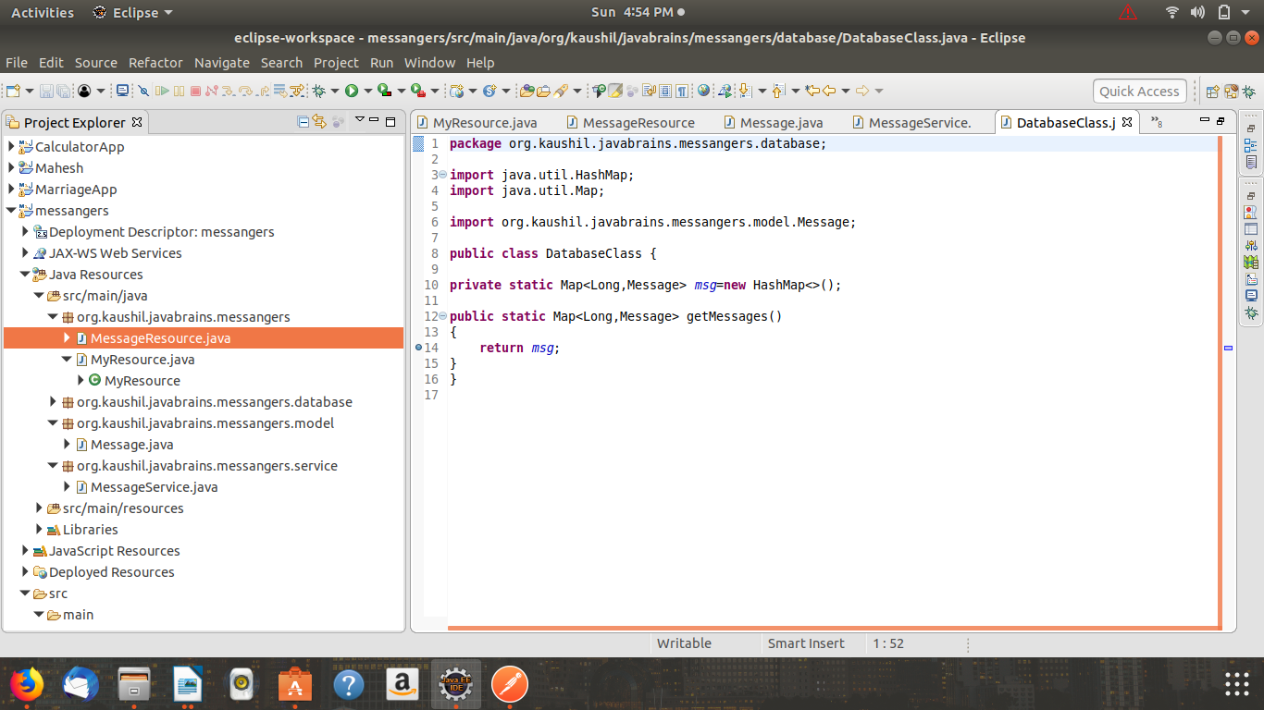
Outputs are as follows:
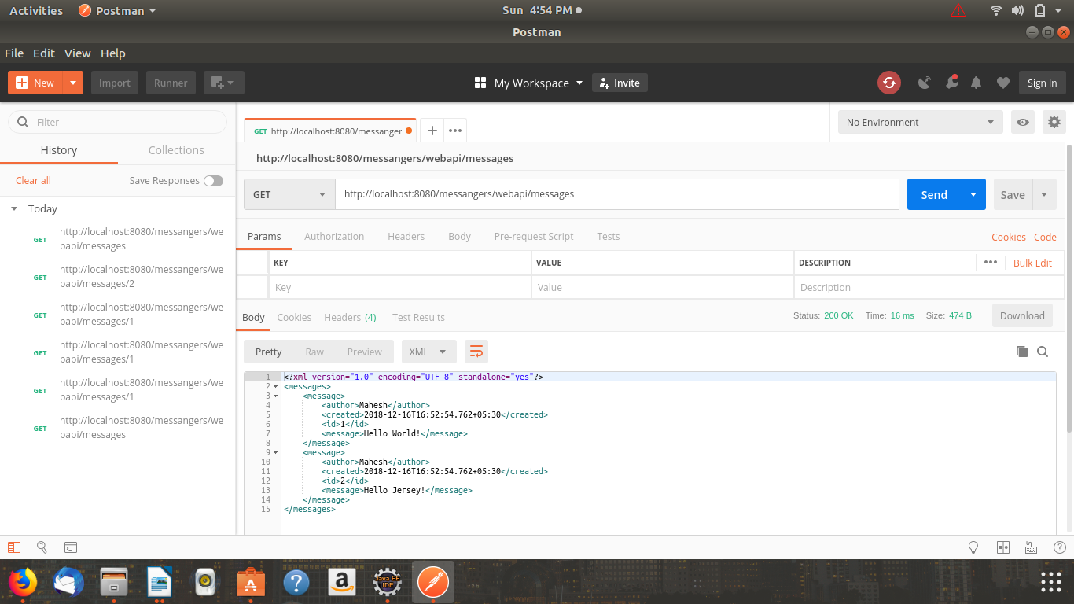
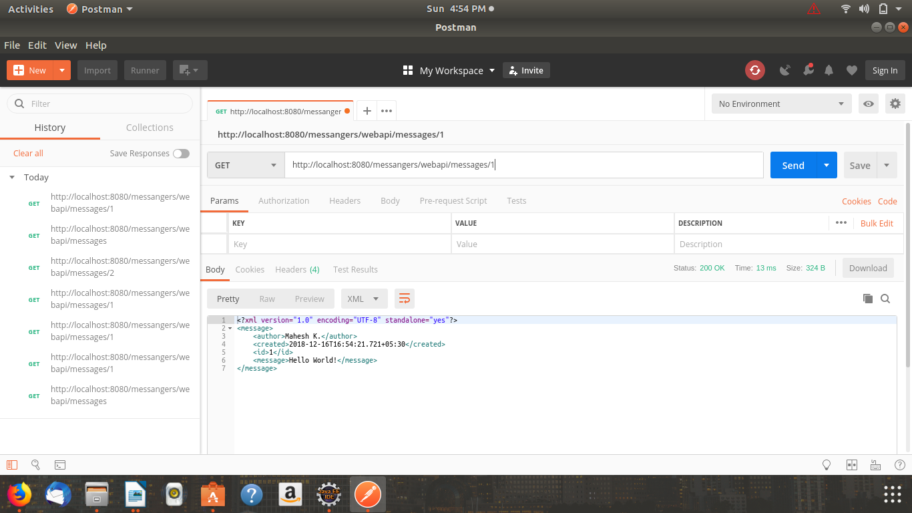

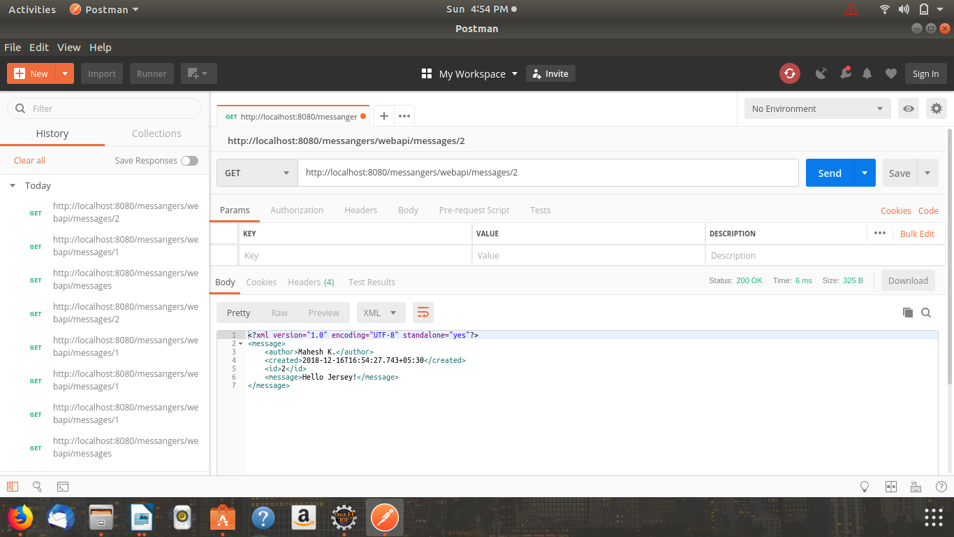
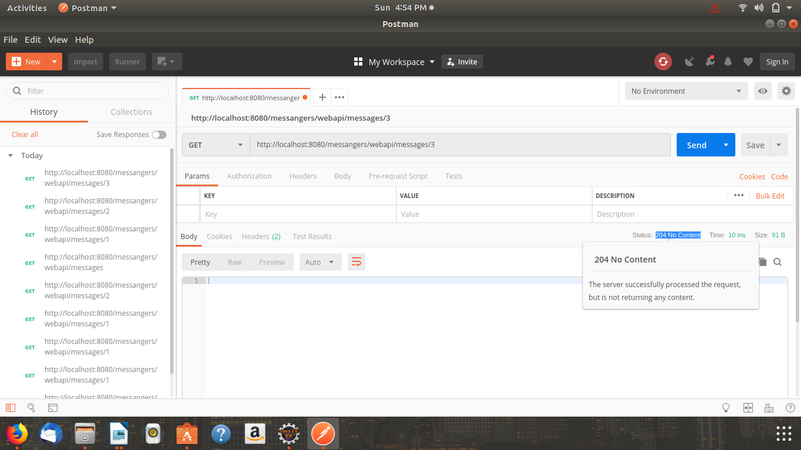
We used @Path("/{messageId}") for passing one parameter in Url also we can pass multiple parameters in one URLas follows

URL: /something/{id1}/name/{id2}

@PathParam("messageId") int id1,@PathParam("messageId") int id2 etc.

Returning JSON Response:

We Used @Produces (MediaType.APPLICATION_XML) to O=Produce XNL Response in Previous Examples.
Now we use @Produces (MediaType.APPLICATION_JSON) to Produce JSON Response.

Uncomment following code from pom.xml.
<!-- uncomment this to get JSON support
<dependency>
<groupId>org.glassfish.jersey.media</groupId>
<artifactId>jersey-media-json-binding</artifactId>
</dependency>
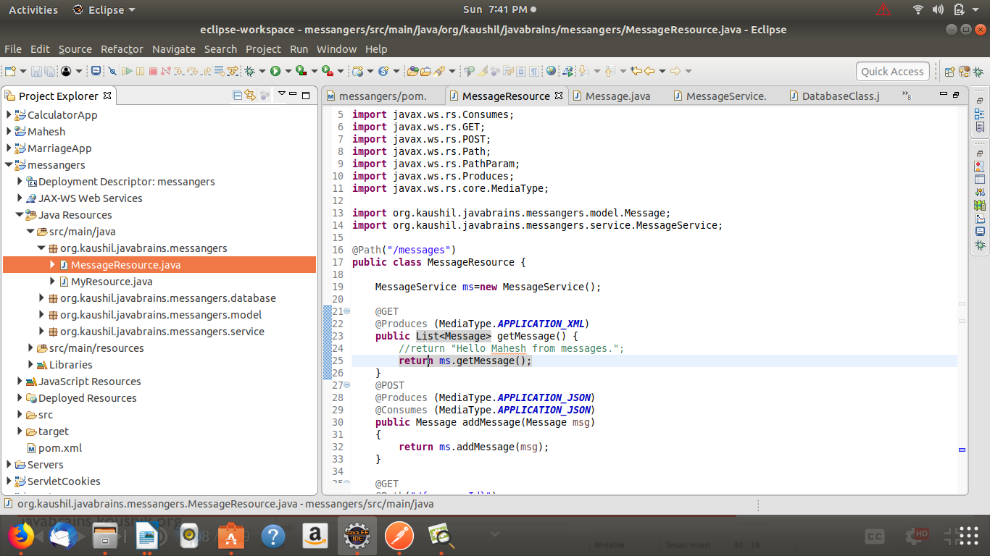
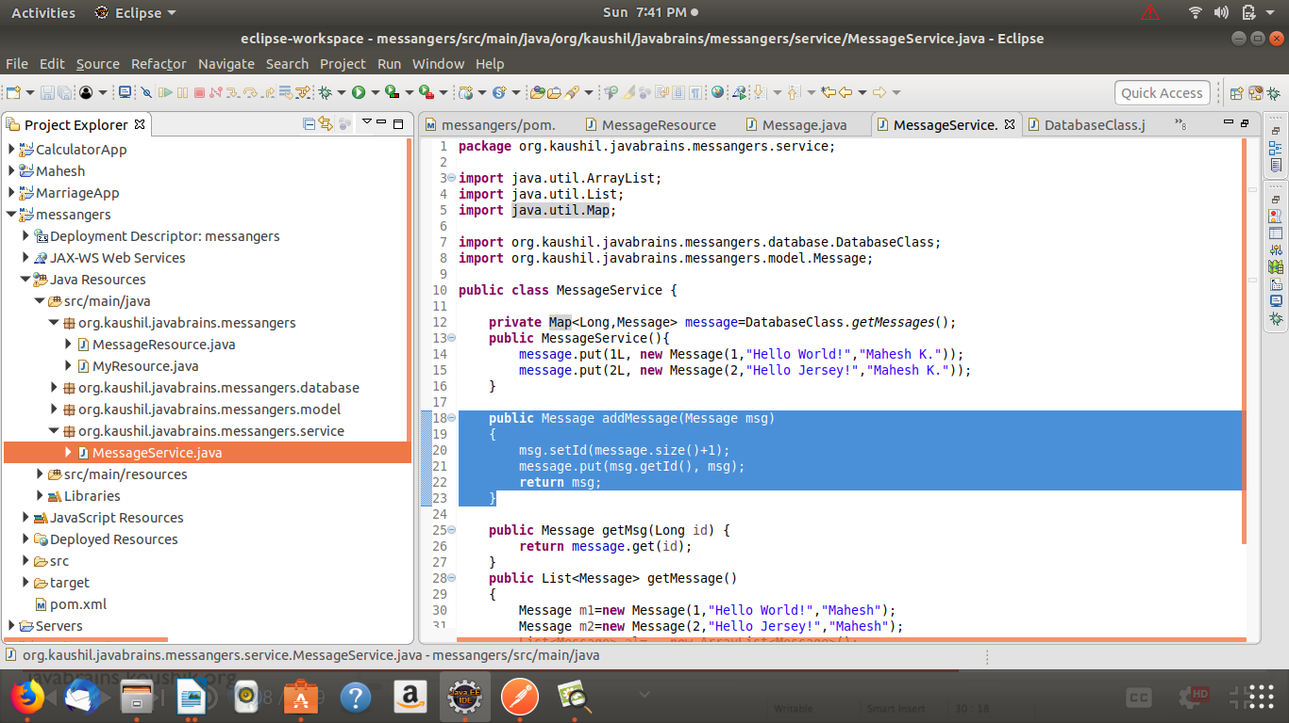
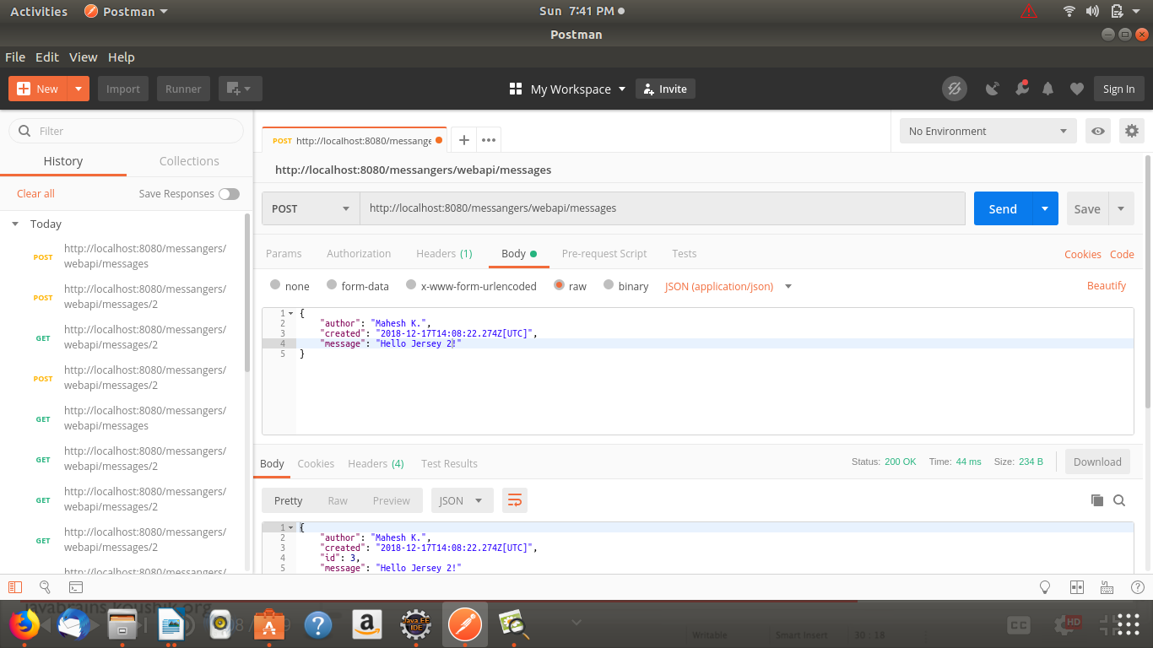
-->

Implementing UPDATE Method:
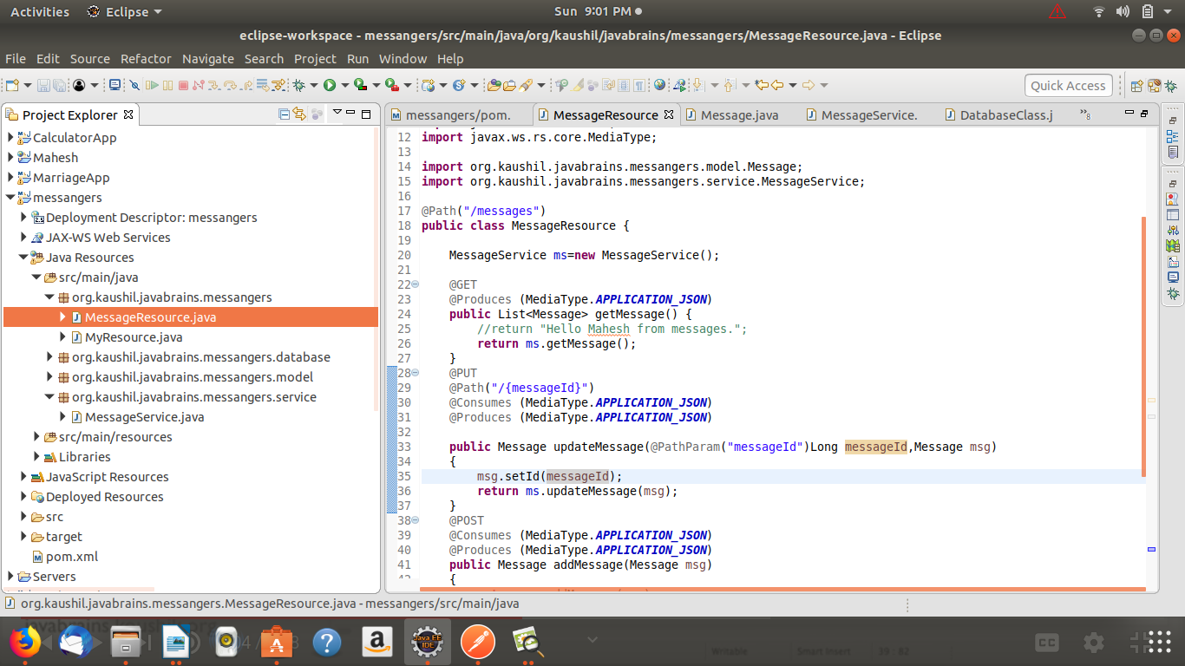
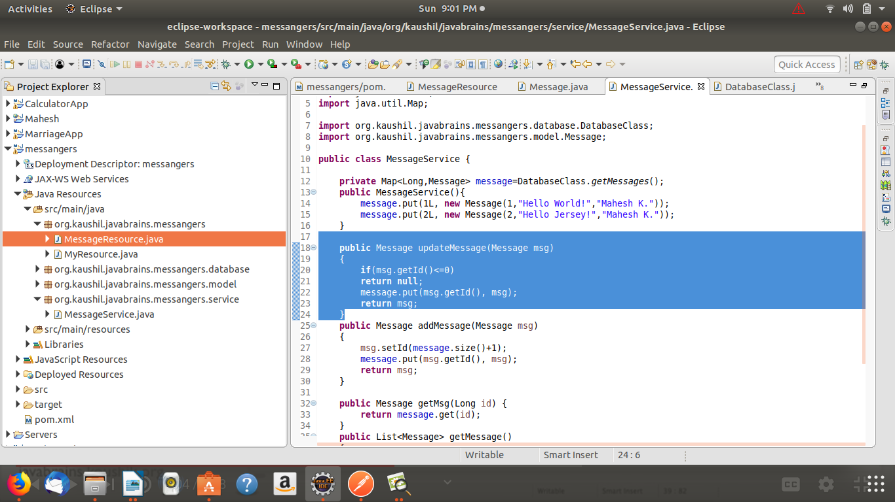
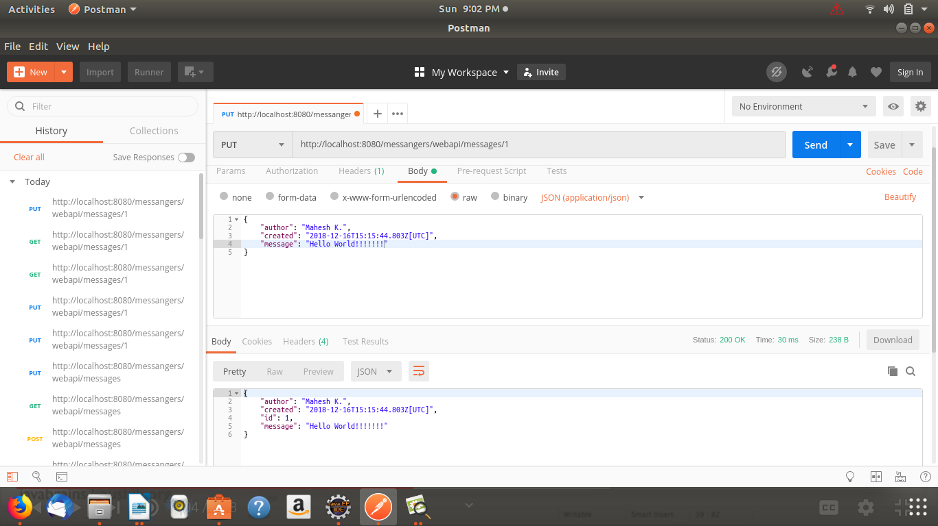

DELETE Method:
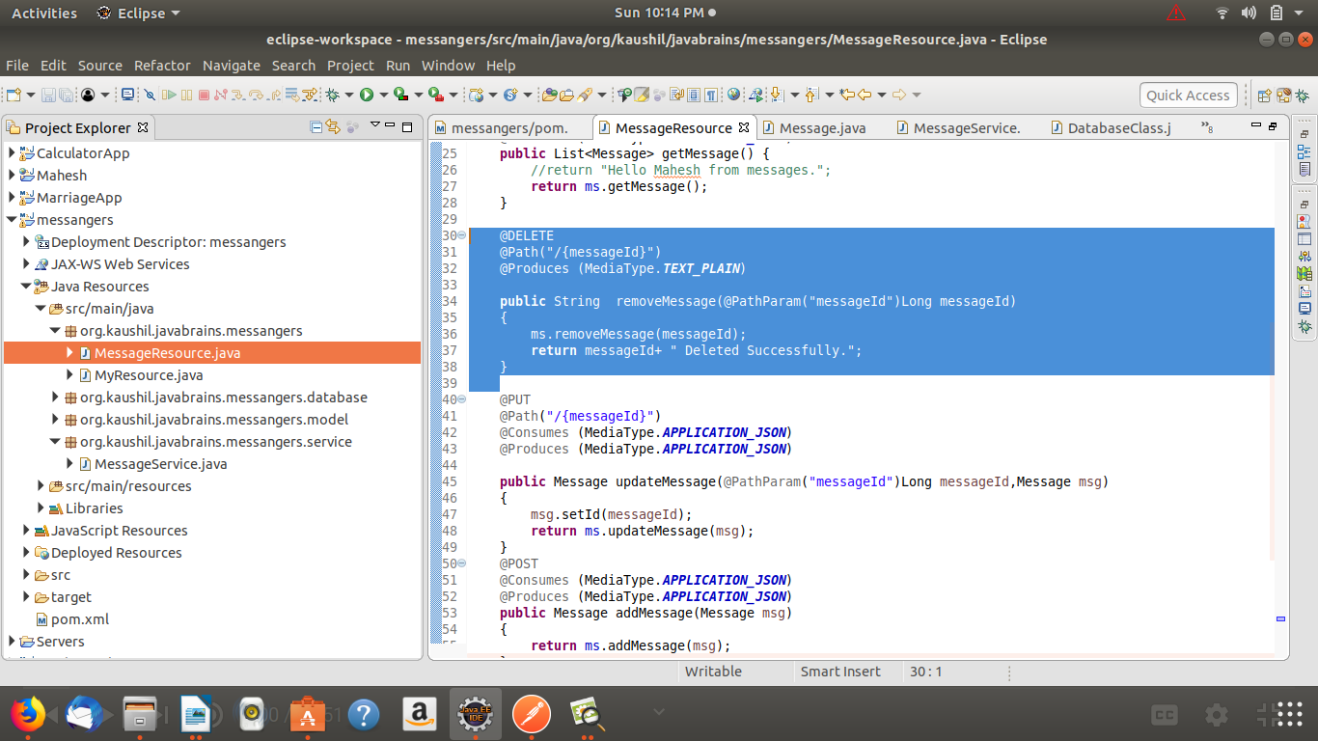

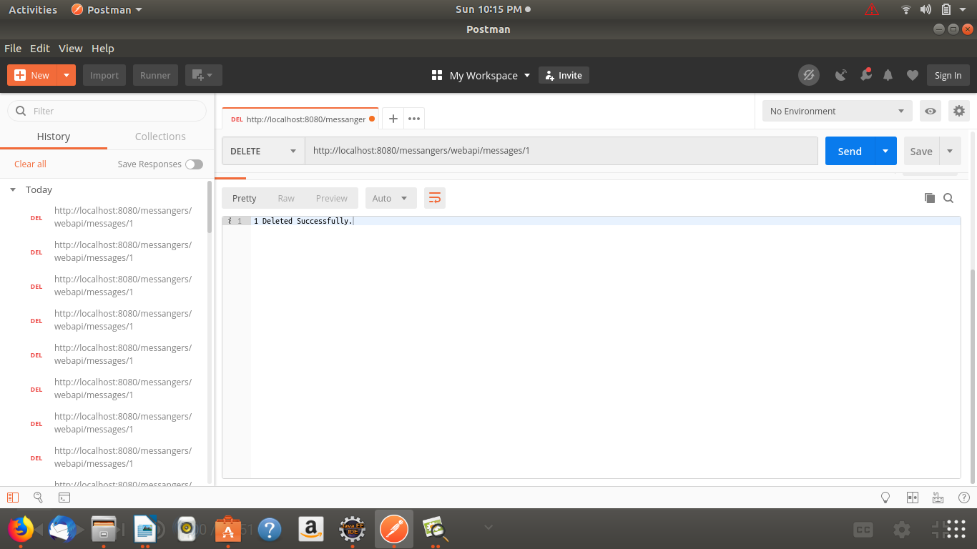
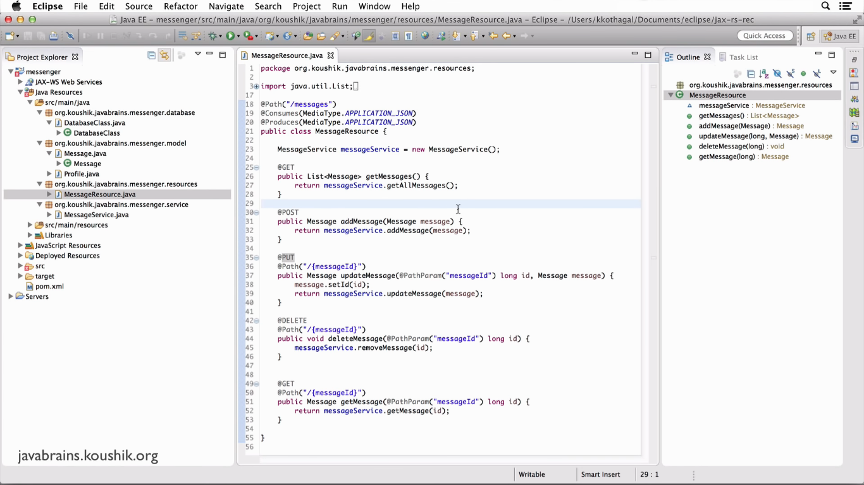
Final Class for Annotations:

PROFILE
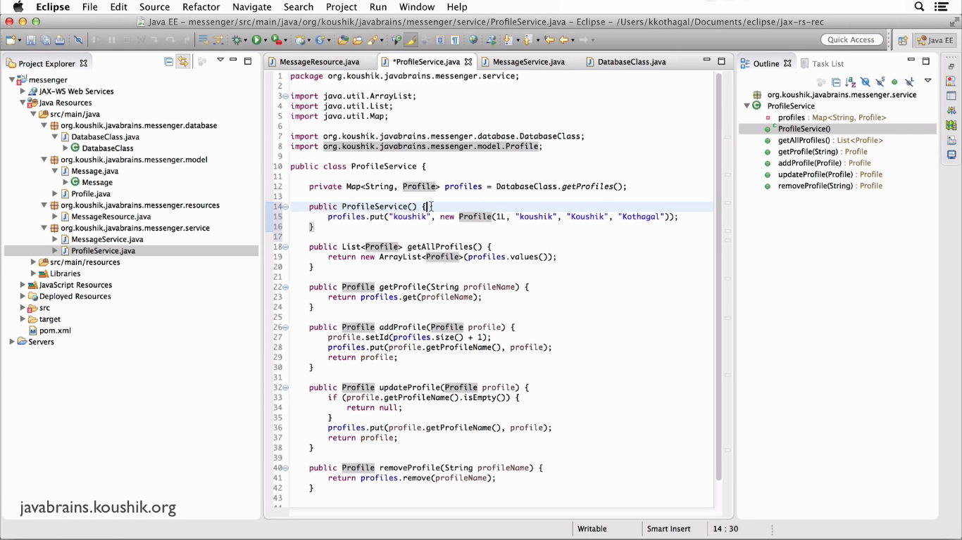
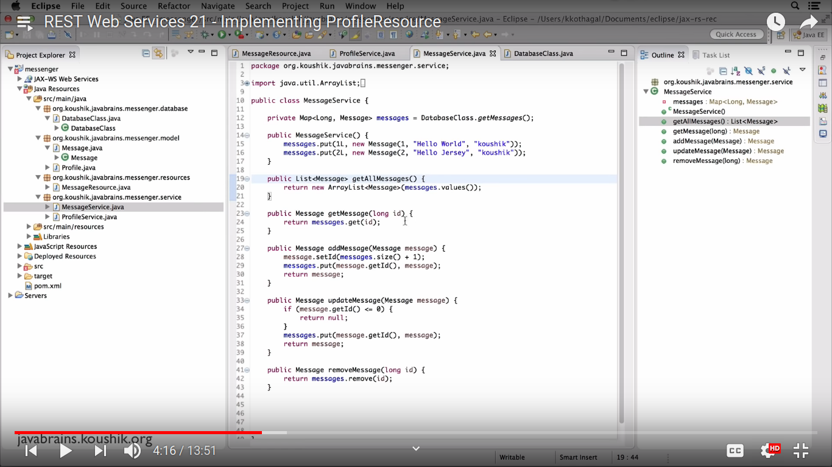
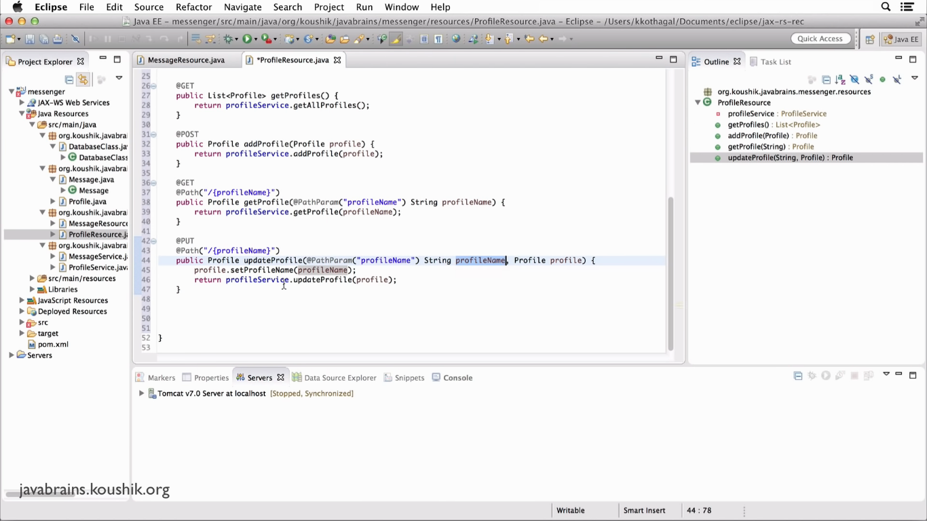
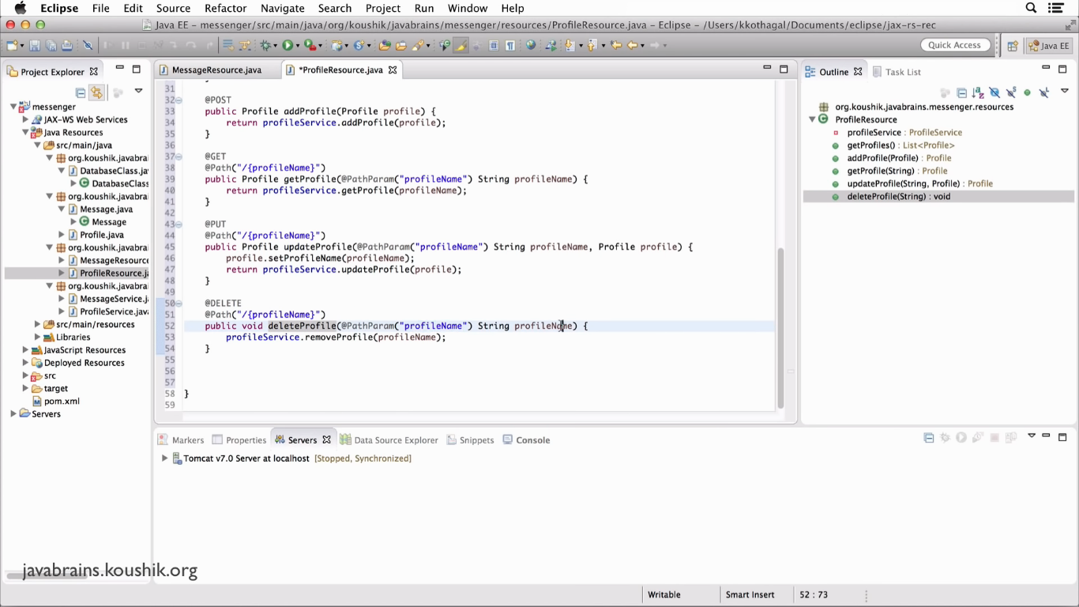
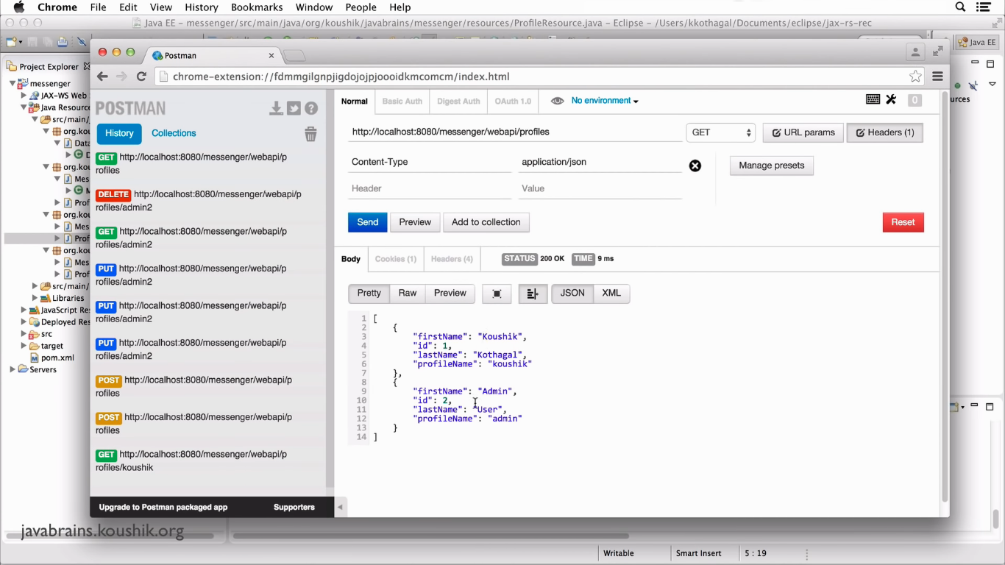
Outputs:

Filtering and Pagination:
Filtering is used for filter the record.

Ex:/messages/year=2018
/messages/start=10&size=20

